**REMEMBERING!**

**FIFTY YEARS FROM THE EXPULSION FROM SOUTH SUDAN (1964-2014)**

**THE LONG AND TORTUOUS JOURNEY TOWARDS A NEW NATION**

**Juba, 27 February 2014**

**“The *works of God are borne and mature on the foot of Calvary…”***

**Comboni (W467)**

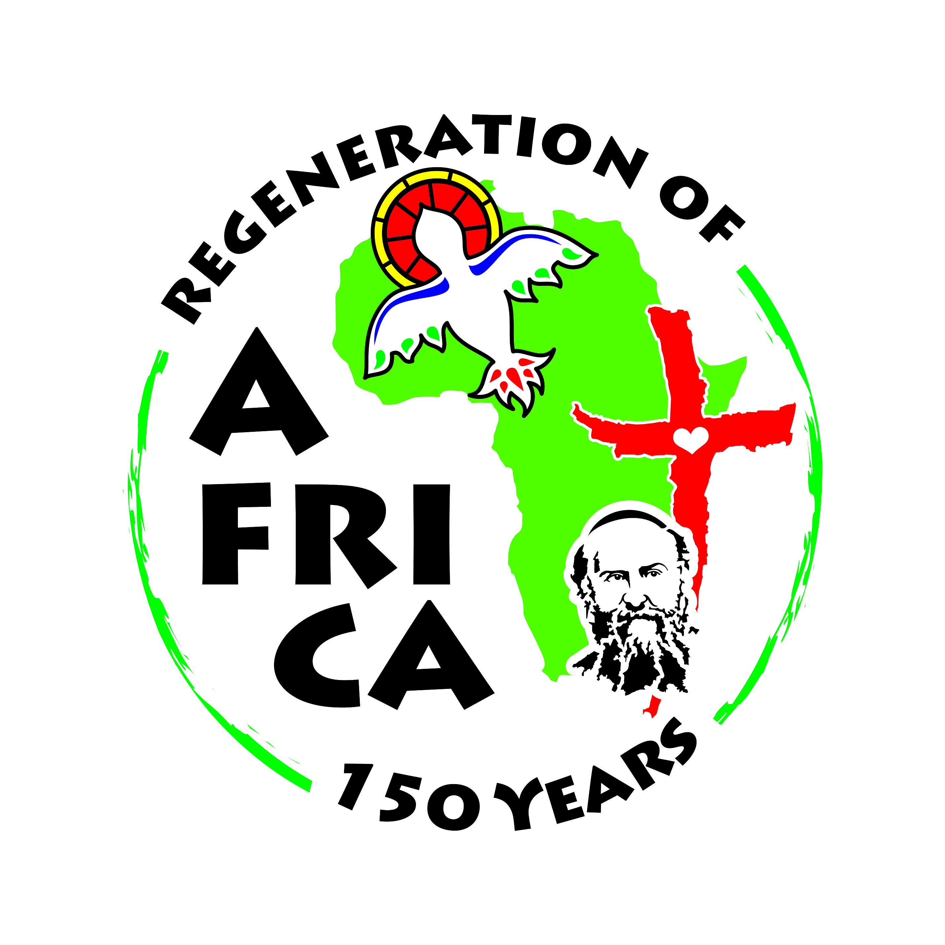

Dear sisters and brothers in Christ,

The God of Peace be with you all. With Comboni we embrace you in Christ.

We write this letter to share with you and with our communities the memory of an event, the expulsion of the missionaries, men and women, from South Sudan, that deeply affected the people and the Church of South Sudan and Sudan. 50 years have passed from that event. We would like to make memory of this “**sacred history**” and celebrate the wonders God has worked out: in situations the most painful, God was able to make something good for the salvation of his people. We make memory of this event in the context of the celebration of the 150 years of the Plan of St. Daniel Comboni for the Regeneration of Africa. The expulsion itself occurred exactly 100 years from the time the Plan was inspired to Comboni. The expulsion: was it a sign or an inevitable misfortune? We would like to read it today as a “**sign of the times**” for the mission in Africa, the Africa that was changing rapidly with the advent of the national independences.

**Remembering the events**

On February 27, the Council of the Ministers of Khartoum Government issued the decree of expulsion of all the foreign missionaries, men and women, operating in the three provinces of South Sudan, Juba, Malakal and Wau. The BBC spread at once the news: **“*The Government of Sudan has decreed that all the foreign missionaries of South Sudan must be deported. The decision concerns about 300 missionaries, the majority of them catholic. The measure has been taken because the missionaries abused the hospitality given them by Sudan and interfered into the affairs of Sudan”.***

Between February 27 and March 9, 1964 all the missionaries were out of the country: 154 Comboni Sisters, 104 Comboni Missionaries, 13 Mill Hill Missionaries from Malakal. The expulsion had started in 1961. On May 17,1964 the Government expelled also the 4 Comboni Missionaries of Mading/Abyei, and Monsignor Edoardo Mason Bishop of El Obeid since he had been previously Bishop of Wau.

**The effects of the expulsion**

The expulsion represented a major event for the mission of **South Sudan** and for the **Comboni family**, and the consequences were many. At that time in South Sudan the *jus missionis* was still in force (it will be abolished in 1974)therefore the Institute was fully responsible for the mission. It had to provide personnel and financial resources and to carry on the work of evangelization.

The expulsion was a real trauma for those who had been expelled and for the Christian communities that remained behind. The missions abandoned were 58. In the church of South Sudan there remained only one bishop (Ireneo Dud, Sudanese, in Wau) and 28 Sudanese priests, including three Comboni Missionaries: Fr. David Urasi, Fr. Peter Magalasi and Fr. Barnaba Denf who would be killed in 1965. There remained three young local congregations of Sisters: the Nazareth Sisters in Wau (started by Bishop Mason), the Sisters of Our Lady of the Victories in Mupoi (started by Mons. Ferrara), the Sacred Heart Sisters in Juba (started by Bishop Mazzoldi). The Comboni Sisters were taking care of the formation of the three of them. As for the brothers there were the Saint Martin De Porres Brothers started in Juba by Bishop Mazzodi and Fr. Marengoni, and the Brothers of Saint Joseph in Wau. In spite of all the difficulties these local congregations found their way and went on.

The missionaries did not abandon their communities. They made a pilgrimage to Lourdes to entrust to Our Lady the situation of South Sudan, especially its Church. They had the consolation of a special audience with Pope Paul VI who expressed to them the solidarity of the whole Church. He encouraged them and expressed his wish that Khartoum might reconsider its decision. Actually the Vatican tried to dialogue with Khartoum Government in view of a possible return of the missionaries and having in mind the missionary work in the North. The missionaries helped also materially through their words in favor of the South Sudanese people, their writing and through fund raising. Bishops Mason and Ferrara were among the most active in this sense.

**“If the grain does not fall and die, it cannot bear fruit…”**

What would happen to the Sudanese Church now that the missionaries were not there? This question was ringing in the mind of many missionaries. Today, 50 years later, the answer seems to be very clear. Out of that experience the Sudanese Church emerged as a local church, with its own hierarchy, the priests, the religious. In 1975 two Sudanese priests were ordained Bishops: Mons. Gabriel Zubir Wako and Mons. Joseph Abangite Gasi. With the ordination of two more, in 1976 the Sudan Catholic Bishops’ Conference (SCBC) was inaugurated. In spite of a violent persecution the Christians of South Sudan held on faithful to the Gospel even to the shedding of their blood: four priests died martyrs, together with a good number of Christians.

The difficult situation in the South forced many people to find refuge in the North and this brought about as a consequence the birth of a Sudanese Church in the North. Some ethnic groups that had been scarcely touched by the evangelization in the South, like the Dinka and the Nuer, came to know the Church in the North, and became Christians.

The congregations of Sisters because of the war continued their formation in the neighboring countries: the Sacred Heart Sisters in Moyo (Uganda) assisted by Sr. Elisabetta Coggi; the Sisters of Our Lady of the Victories escaped to Obo (Central Africa) and were assisted by the Comboni Sistsres Melania Morelli and Flora Teresa Rebellato. When the war was over, they returned to Sudan and at the invitation of the SCBC the Nazareth Sisters of Wau and the Sisters of Our Lady of the Victories merged to form the Missionary Sisters of the Blessed Virgin Mary.

The expulsion from South Sudan was also the occasion for the Comboni Institutes to open communities in other African Countries. The Comboni Missionaries went to Congo, Central Africa and Tchad in order to accompany the Sudanese refugees. They opened new missions in Uganda (Moroto), Ethiopia (Awassa), Togo, and elsewhere. The Comboni Sisters opened a community in Kenya that would become a new province. The missionaries, male and female, scattered everywhere in Europe, Latin America and Middle East making present the Comboni Charism.

The expulsion was also the occasion for the two Institutes to give emphasis to the formation of local pastoral agents (priests, religious, lay people) and the promotion of Comboni Vocations. New African Congregations with a missionary spirit were started, like the Apostles of Jesus and the Evangelizing Sisters of Mary; History was teaching that thye motto of Comboni **“Save Africa with Africa”**was a mustfor the work evangelization in South Sudan and in the world. If other expulsions occurred, the Christian communities would continue to have their pastoral agents and their missionaries.

The 1964 expulsion was certainly a moment of great sufferings for the missionaries and even more for the people of South Sudan. And yet, when we look at it in restrospect, we may discover in it an event of salvation. The Lord has been able to draw from these events, in themselves difficult and painful, new fruits. Making memory of those events helps us to re-read and re-comprehend, and the effect is that it becomes a moment of thanks-giving and appreciation for what has come out. The local Sudanese Church that was born out of these events is surely a gift for the Sudan, both North and South, and for Africa as such in continuity with the dream of Comboni to **Save Africa with Africa**.

**The situation of the South Sudan today**

By re-reading events of the past and finding in them clear signs that they became history of salvation, helps us to look with hope and love also to the present history of South Sudan.

On July 9, 2011 South Sudan became the 54th country of Africa. Independence was celebrated with rejoicing while dreaming of a bright future of harmony and peace. Instead only after two years of work for the building up of the nation, suddenly things returned to ground zero, on December 15, 2013. The troubles started in Juba but rapidly spread over the whole nation bringing sufferings, death, destruction and division. Within so much evil, there were acts of genuine love inspired by the Gospel: ”***Love your enemy, pray for those who persecute you***”. In this context the Bishops of Sudan, and South Sudan , in their last Assembly held in Juba in January 2014 wrote the exhortation : “***Let us re-found our Nation on a New Covenant*”.** They re-design the work of evangelization in the short and long terms, placing **Reconciliation**at the top***: “Reconciliation –they write- must become the first priority at all levels, in the society and in the Church. We are convinced –they write- that we are at a turning point of the history of South Sudan. South Sudan cannot be the same. It is time for our Nation to rise from the ashes. Now is the time for a new Nation. We commit ourselves for a reconstruction that is very much necessary for our new Nation. The task is hard and uncertain, but we remain in solidarity with our brothers and sisters who are in need of our support. Let Our New Nation rise!”***

**Looking ahead with faith and hope**

When the expulsion took place in 1964, we the disciples of Comboni, men and women assumed the vision and faith of Comboni and made them ours. A great Cross to be carried but we continued our journey. “***The Catholic, who is used to judging thing in a supernatural light, looked upon Africa not through the pitiable lens of human interest, but in the pure light of faith. There he saw an infinite multitude of brothers who belonged to the same family as himself with one common father in heaven” (W 2742).***

In the same way, we believe and pray that the South Sudanese people will come out of this crisis stronger than ever, ready to face the challenges that history and life imply. We believe that the people of South Sudan will rediscover the national identity to build up together their nation with the help of God, overcoming the evil of tribalism and division. It will take time. People look at the Church and at the missionaries with great hope with a strong desire of seeing us walk in the direction that the Church is offering in an attitude of purification together and within the society of which we are part. God has not abandoned his people!. God has never abandoned South Sudan during the long years of war . Ours too will be history of salvation for the people of South Sudan. We are called to be part of it, and write this section of history with his people, as our ancestors in faith did. Without fear and with great courage ! Looking at the 50 years ahead!

May the God of the History, may St. Daniel Comboni, the Martyrs of the Mahdiya, St Josephine Bakhita bless us in the journey towards the future with joy and trust in Him.

**“Courage for the present and especially for the future” St. Daniel Comboni**



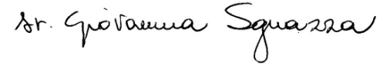

**FR. DANIELE MOSCHETTI SR. GIOVANNA SGUAZZA**

**PROVINCIAL SUPERIORS OF SOUTH SUDAN**

