MALAWI/ZAMBIA:

ONE OF THE MAJOR FOCUS
OF THE EVANGILIZATION PLAN OF COMBONI
WAS HUMAN PROMOTION

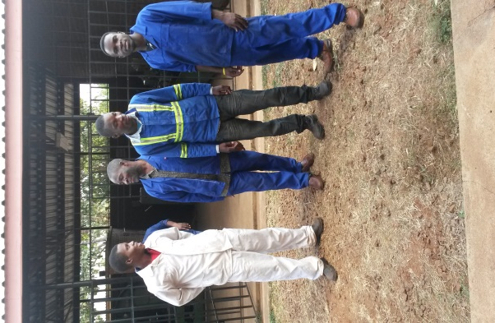
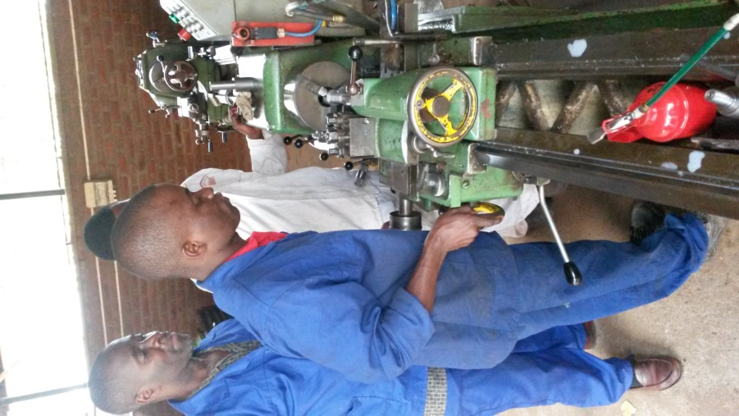
The Province of Malawi/Zambia has taken this human promotion very seriously by opening one Human Promotion and Development Centre in each country of the Province: Comboni Technical College in Malawi and Youth Development Center in Zambia. These projects are meant to promote people`s lives and are empowering young people to be the protagonists of their future, their family and country. The two institutions are established to give concrete answers to the major problems of the youth in order to give them the chance to build a brighter future. They pursue the following objectives:
- To provide them with practical and quality training in Agriculture, Welding and Fabrication, Carpentry and Joinery, Electrical Installation and General Fitting.
- To give them human skills for their personal growth and maturity that enables them to become good and responsible citizens.
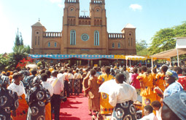
- To give them entrepreneurial knowledge and skills which will help them to initiate enterprises when they finish their training.
- To assist their fellow youths to take an active part in the up building of their communities.
- To promote spiritual values that can help them in assuming Christian commitment in the up building of the Kingdom of God.
So far we have produced good results countrywide with the fact that they are getting jobs and reasonable salaries after graduating from our these institutions. This reality has been the pride of the Province and the Congregation.

