LEER (SOUTH SUDAN – UNITY STATE)
WALKING WITH THE PEOPLE
During the times of war and peace

We have chosen our community of Leer, situated in Unity State, one of the three most affected states of the Republic of South Sudan by the war that continues from December 2013. It represents the struggle, sharing and the common cause of our Comboni community and its people in this particular suffering time of our new and youngest nation in the world. Our confreres and the sisters of Leer have been evacuated twice with great risks in the last two years and witnessing a total destruction of the town and killing of the people. Leer symbolizes all our confreres and sisters in the communities of the Province of South Sudan who are dedicated to the People of God in this Holy Land of St. Daniel Comboni. It is a total dedication and sharing with the People up to the risk of our lives and in communion and solidarity with the poor and the People of God. To announce the Good News is to live fully and witness the COMMON CAUSE and LOVE of St. Daniel Comboni for God and its People.
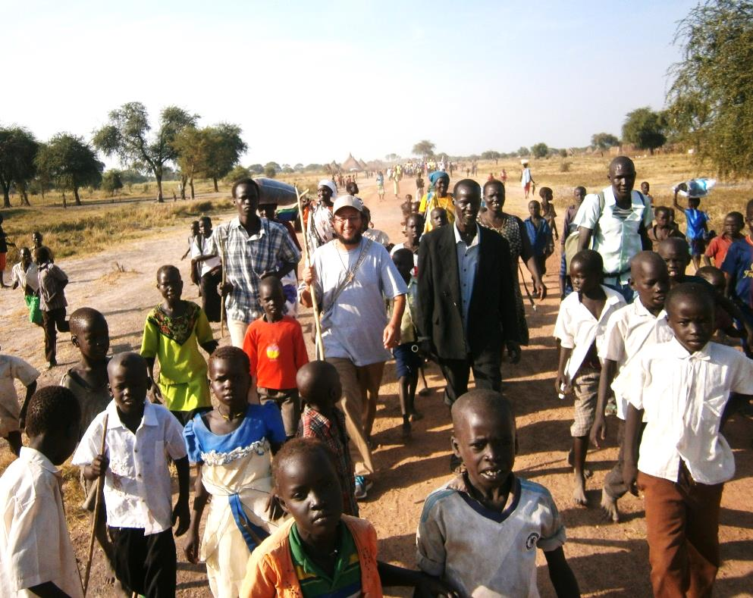
- Our community of Leer was entrusted, in 1996, with the pastoral care of the Nuer people, in the Saint Joseph the Worker Parish, which is under the Diocese of Malakal, in South Sudan.
- When we arrived we encountered hundreds of Christian communities well organized and led by lay ministers: catechists, without the support of any Church´s institution or structure.
- Walking with the catechists has meant to be with them, accom-pany and work side by side with them in the evangelization they were already doing even before our arrival.
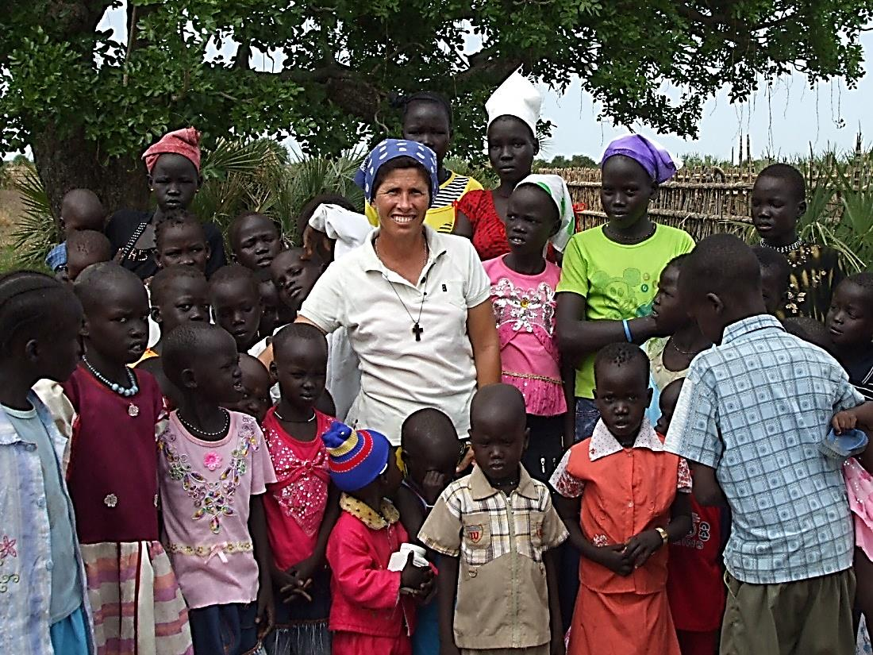
- Walking with the people in times of war has meant to be with them and shared their sufferings, pains, tears, joys, hopes and dreams, during the independence war and the actual struggle for power.
- War and looting has reached the area of our parish in 1998 in Leer, 2001 in Nyal, 2014 in Leer and, again, 2015 in all the counties of our mission-parish: Koch, Leer, Mayandiit and Payinyjiar. This year 2015 has been very tough because it has caused a lot of suffering and death to people.
- Walking with them in time of war has meant to be a presence that keep the small flame of hope alight and promote peace and reconciliation where there seems to be room only for violence and revenge. Proposing the culture of the Gospel over the culture of violence.
- Walking with them in times of peace has meant to move forward with them during the process of birth of the new nation. We shared their dreams and worked for the integral human promotion through the education, the agriculture, small income generating projects.
- Walking with the people in times of peace has meant to do an integral process of evangelization. We announce and witness Jesus Christ and his Kingdom of love, justice, and peace. Priority is given to the Small Christian communities, formation of Christian leaders, teaching on and celebration of the Sacraments, human promotion, education and awareness to JPIC issues.
- We work in close collaboration with the Comboni Missionaries Sisters.
- There are many challenges:
  - how to make the Gospel values accepted and integrated in the life of the people we work with.
  - The spirit of revenge prevails
  - There is an effort to reach a true reconciliation among clans and different tribes.
  - In spite of all the difficulties, we continue to walk with the people hoping for a better future when enemies will be reconciled in Jesus Christ.

