***A Handbook for internal use only***

On-Going Formation Centre

Comboni Missionaries

Via Luigi Lilio, 80

Rome

**INTERCULTURALITY**

**THE CHALLENGE OF FORMING OURSELVES IN INTERCULTURAL COMPETENCE**

*Multicultural communities have the value and importance of being a prophetic expression and sign, a gift to the Church and to society for the value given to fraternity  
rather than differences in ethnicity, language or culture.*

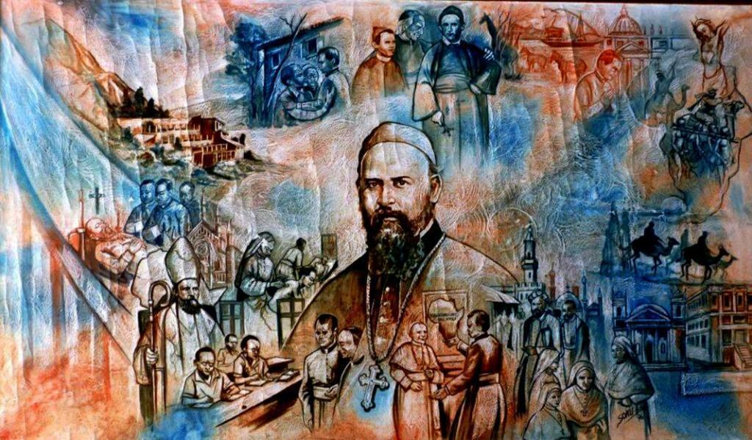

**FROM THE RULE OF LIFE**

**No. 18 - INTERNATIONALITY**

*Composed of members from different countries and cultures, the Institute is an expression of brotherly friendship and solidarity, a sign of the catholicity of the Church. It gives concrete witness to that fellowship in the Spirit which is proper to the People of God. It does not suppress diversities but makes them factors of unity.*

*The missionary acquires an international disposition and outlook only gradually. By personal effort and adequate training, he becomes able to compare and share views and experiences originating from the diversity of cultures and to understand and respect other people in their differences. (RL 18.1)*

*The Institute endeavours to facilitate the exchange of ideas, experiences and values between the Local Churches, particularly through the deployment of personnel from different nations. (RL 18.2)*

**N.B.: Internationality and consequently multiculturalism belongs to the DNA of our Institute, as the founder, St. Daniel Comboni, wanted it.**



**FROM THE 2015 CHAPTER ACTS**

*We are all invited to abandon complexes and prejudices, the suspicion and the fear of difference that the other person embodies. Instead, we are called to open ourselves to mutual trust, to the knowledge of the culture of the other, to respect and to the value of differences. The awareness and sharing of our richness and the relativization of cultural, religious and methodological visions will help us to face the inevitable tensions. (CA 2015, 47.4)*

*The certainty of our common vocation and the charism itself are a source of interpersonal communion that allows us to challenge the disruptive forces that can arise from differences. This becomes a prophecy of our mission to build a new humanity. (ACA 2015, 47.5)  
The local community is the privileged place to live these dynamics: in shared prayer, in community meetings and in initiatives on the theme of interculturality, in lifestyle choices and programmes. The responsibility for this journey is for each member of the community, especially the Local superior and that of the Circumscription. (CA 2015, 47.6)*



**What indispensable knowledge is needed?**

What do you expect from this Workshop?

What is intercultural competence?

Which are the necessary attitudes and skills?

**INTRODUCTION**

This Handbook was initially prepared in view of the courses that take place in the Comboni Centre for On-going Formation in Rome, as an aid to the presentation and study of the theme of interculturality. This phenomenon is of great relevance for our Institute, as underlined by the 2015 General Chapter (Cf. CA 2015, 47.6), as evidenced by the generally more and more multi-ethnic religious communities and by our increasingly globalized world. The basis of this text is the material that Sr. Martha Seide, a Salesian sister from Haiti, presented during the Comboni Year of Ongoing Formation in November 2017. We thank Sr. Martha for putting at our disposal the material that she shared with us. The 9th chapter entitled *Multicultural identities in multi-ethnic religious communities*, is inspired by a conference that Fr. Giuseppe Crea MCCJ gave during the same course.

This material, organized by Fr. Siro Stocchetti, MCCJ wants to facilitate the modality of the workshop in order to make everyone's participation more active and engaging. The goal is to activate in us a process that allows us to develop intercultural competence, that is to acquire greater knowledge, awareness and understanding in view of greater ability, to interact in the daily life of our community life and in our ministry in a way appropriate and effective with people from different cultures.

The Handbook is divided into nine chapters and aims to:

1) clarify the fundamental concepts used

2) understand the mechanisms that take place in the relationship with people of different cultures through reflection on ourselves, as subjects having a cultural identity (self-awareness) and the discovery of the lines of force present in the other culture.

3) learn to decentralize, that is, to become aware of how our cultural baggage (rules, values, habits, communication, etc.) conditions our relationship with the others

4) identify the obstacles and know the dynamics that promote understanding and effective communication with people or groups of different cultures.

5) place the intercultural relationship in the context of the consecrated and missionary life  
6) make proposals for the way forward

The main issues addressed are: forming and training for intercultural competence, cultural shock, sensitive areas, critical incidents, intercultural communication, stereotypes and prejudices. Each chapter can be used for a meeting, articulated in these moments:

1) the presentation of the theme using the material offered here as a basis

2) a time for reflection and personal prayer, oriented by the questions that conclude each chapter and the personal elaboration of the exercises that are proposed

3) sharing in community or in groups on the personal reflection and proposed exercises.

Each sharing should lead to a concrete commitment: an attitude to be taken or an initiative to be implemented. The Handbook ends with the invitation to elaborate at the end of the workshop the community commitment to grow in inter-cultural competence. The fundamental attitude required is to get involved. The effectiveness of this activity is measured in its daily resonance of our relations with confreres and people of other cultures that we meet in our ministry. The aim is to assume attitudes in our everyday life oriented by a greater awareness of the challenges and values that we encounter in living in a multicultural context. This implies a journey of conversion in our relationships in the light of the Gospel and of the Comboni charism.

Our Institute has planned the year 2019 to reflect, study and deepen the theme of interculturality. In this context, this Handbook is offered to the Circumscriptions as a handout to organize workshops on this theme at the various levels of the Circumscription, apostolic and formation communities.

*Rome, October 22nd, 2018*

*General Secretariat of Formation*

**Chapter 1**

**THE CHALLENGE OF INTERCULTURALITY**

**I. INTRODUCTION**

**1. WE ARE ALL EQUAL AND DIFFERENT**

**EQUAL **

** DIFFERENT**

We are all the same and different. There are no doubts. It would seem a foregone statement, but that we can easily forget with the negative consequences that this entails in our relationships.

* Equal as human, in this common identity we can meet, dialogue, understand, be in solidarity, grow in a journey of humanization
* Recognizing and accepting our diversity as concerns culture, character, education, age, experience, ...

**2. INTERCULTURALITY**

Demands:

1) the ability to live well in different cultures, see the other as a richness, ability to adapt and accept the different, integrate different cultures, unity in diversity  
2) freedom for the encounter with the different  
3) attitudes of patience, listening, openness, acceptance, humility, dialogue, observation, forgiveness, silence, will, reading, relativizing  
4) the skills to collaborate, risk, dialogue, reflect, reconcile, respect, learn languages  
5) the knowledge of oneself, from a psychological point of view and of the anthropology of one’s own culture.

**3. INTERCULTURAL COMPETENCE**

It is the ability to set in motion and coordinate the internal resources possessed and the external resources available to positively achieve the experience of the personal transformation process vis-à-vis the other.

*“Interculturality is learned as man learns to walk: from experience and from the risks taken and accompanied. Intercultural learning is not achieved by a simple transmission of didactic knowledge, or by a mimicry of behaviour, but by experiential construction: the apprentice, guided by a guide, transforms himself producing the knowledge and skills of which he has need.”* (Marc Thomas)

The strategies implemented in many countries to manage the plurality of cultures have helped to develop the so-called assimilation, integration, multiculturalism and intercultural models.  
If in the consecrated and missionary life, formation today requires the model of integration; in the management of relations between cultures, interculturality must be assumed as a competence.  
What comes into contact is not national cultures or identities, but people.  
Acquiring this competence requires continuous learning that questions the person at three levels of his or her existence:

* the personal cultural identity to be continuously explored
* the knowledge of the other to be discovered
* the management of the relationship to be optimized towards the fruitful meeting with the other.

In apostolic consecrated life, this process is situated in the heart of a community convened by the Lord, to live together and to share the same mission according to a specific charism. In this context, interculturality is a vital element for the future of the Institutes of apostolic life.  
According to Martyn Barrett, there are four essential components of intercultural competence: attitudes, skills / abilities, knowledge and behaviour.

**4. THE DEFINITION OF SOME CONCEPTS**

1. Cultural Identity

* The identity that each individual builds depends mainly on the relational experience with the people in in his own environment.
* Today the contact between people belonging to different cultures has increased, both in civil society and in the context of religious life

2) Cultural transmissions

* A cultural group can pass on its behavioural characteristics to subsequent generations through teaching and learning

3) Acculturation

* While inculturation is the process by which the group usually incorporates children into culture and with which the child acquires appropriate behaviour ...
* Acculturation refers to the cultural and psychological change caused by contact with other people belonging to different cultures, with different behaviours.

**\* Questions for personal reflection and sharing**

1) What makes us different? What are the biggest differences that emerge from our relationships?  
2) What do I have in common with the confreres in my community? What is our common identity beyond cultural differences?  
3) How are the differences related to our different cultures managed? In what ways could we improve in fidelity to the Gospel and to our Comboni charism?



**Chapter 2**

**PERSONAL IDENTITY**

**AND EMPATHICAL RELATIONSHIP**

1. **DEEPENING THE PERSONAL IDENTITY  
   IN ORDER TO BECOME AWARE OF ONE’S OWN REFERENCE FRAMEWORK**

The relationship with the other is often hampered by the lack of knowledge of one's own culture, stereotypes or cultural prejudices towards others. So the starting point of intercultural competence is the culture of each individual (self-awareness) As human beings we are shaped by historical, family, national, religious antecedents that have marked our way of relating to others.

1) **The decoding of cultural representations at a general level**

Such as: cultural shock, sensitive areas and critical incidents, cultural models and dimensions, intercultural communication, prejudices and stereotypes. It is necessary to understand these mechanisms activated in the relationship in a multicultural situation starting from the reflection on oneself, as subjects bearing an identity and a culture.

**2) The necessary path of decentralization**

To become aware of one's own cultural references, to distance oneself to reach a relativization of one's own points of view with the aim of achieving a certain cultural neutrality which is not synonymous with the denial of one's identity, but with a controlled recognition of one's identity. From this point of view, the concept of identity is very linked to the process of decentralization.  
  
**3) Acknowledge the equalities and assume them in daily life**

It is important to recognize the differences, but at the same time we are called to achieve what is common to us. When we stay in contact with another culture for many years, at the end of the long road to discover the different, there is the joy of meeting as people, of finding ourselves united in the same humanity. This similarity is strengthened also at the level of not only cultural identity, but also of Christian anthropology, charism, etc. In fact, the centre of the community is Jesus Christ, the only reason for our living and self-donation.

**4) The formative needs for a process of decentralization**

To become aware that each person carries within himself the cultural heritage with its riches and its limits, knowing how to look with detachment in order to understand one's cultural representations, social and psychological conditioning, learn to identify the prejudices of one's own culture towards others with all the racism and intolerance implied.  
Assume reality as it presents itself, with the commitment to reinforce its positive aspects and the desire and the will to deconstruct the shadow side, to free oneself from the linguistic stereotypes that reveal a racist mentality. Hence the need for the purification of memory, asking each other for forgiveness of cultural offenses, even if unaware.

**5) The need for the deconstruction methodology**

To question one's own pre-comprehension, to review one's own ideas, in view of a new understanding of reality and history. It is necessary to "build deconstructing"; it is not primarily a question of deconstructing the culture of the other, but of one's own culture.

1. **THE COMMITMENT TO ESTABLISH AN EMPATHICAL RELATIONSHIP WITH THE OTHER TO UNDERSTAND HIS REFERENCE SYSTEM**

Once the cultural inheritance has been thematised, freed and the wounds of a cultural nature healed, committed to a continuous purification of memory and mentality, we can progressively move our gaze to see the other as he is in the present situation and not as the dominant culture presents it.  
  
**1) Becoming aware of the cultural diversity of the other with respect to his own culture**For example regarding:

* the style of communication: direct or indirect, the implicit or the explicit
* body language: gestures, mimicry, rituals, non-verbal
* high or low contextuality
* the concept of monochromatic or polychrome time
* the vision of the past, present and future
* waiting time and realization or reaction time
* the image of authority
* the relationship to oneself
* religious sensitivity
* Politics
* the perception of the body, of suffering, of fatigue, of death, etc.

**2) Penetrating the representation system of the culture of the other**This requires:

* an attitude of detachment from one's own system of values ​​(decentralization), openness, curiosity and humility towards the other culture
* appropriate or adapted time, means and methods
* learning the local language, having the 'passion' to communicate.

Promoting in the community:

* sharing strong moments and significant elements of one's culture
* investing time and energy to talk and listen, to try to understand the real motivations, the real values ​​that are within the behaviours
* giving the necessary time to experience the cultural shock to those who arrive in the new culture.

In the openness and in the interrelationship the other is welcomed and accepted in his likeness to us while valuing his difference, as a gift. This process must be carried out together to achieve the desired results and promote continuous dialogue.

**\* Questions for personal reflection and group sharing**1) List the elements that most characterize your culture of origin. What do you value most and which aspects has life experience helped you to relativize?  
2) How have you lived and are you living the process of decentralization from your culture to open yourself to the culture of the missionary context where you have carried out or are you doing your service?  
3) What was your experience of living in a multicultural community? Difficulties, challenges and joys.  
4) What has hindered and what has helped the meeting and hospitality in diversity?

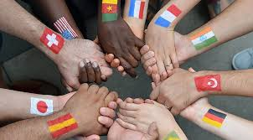

**Chapter 3**

**DIALOGUE FOR BUILDING COMMUNION IN THE MISSION**

The believing person who has experienced the love of God, loves and is sure to be loved by those who share his life. This love manifests itself in the opening of the heart, in the attitude of welcoming the other as he is, even in its limits, without judgments or prejudices. The conviction is strengthened that the other does not want to offend, we are seeking together the truth, we want to grow together. This is a necessary premise to start an authentic dialogue; it is not a foregone reality, it needs to be acknowledged, remembered, affirmed and supported. This requires mutual trust and true belief.  
  
**1) Rereading the relationship**In the awareness that interculturality is a shared choice, we open ourselves to dialogue to reflect on the experience in progress, on the relationship under construction. This reflection / re-reading helps:

* to eliminate any ambiguity
* to decode intercultural dynamics, particularly invisible ones
* to unmask the fears of exposing oneself
* to call reality with the proper name
* to free language and cultural stereotypes from any racist residue.

**2) The courage to seek and promote dialogue**It is the condition *sine qua non* to advance together satisfactorily.  
If today dialogue is so difficult, and relationship remains the biggest problem of our communities, it is perhaps because for so long we have not had the courage to face the fraternal lifestyle in a lucid and effective way in community. We lack the method, and we do not know how to invent it.  
  
**3) The importance of communication in formation for intercultural competence**With all its implications of perceptions, different styles, languages, gestures, dealing with non-verbal communication in general, we need to promote activities that help us to become more aware of the functioning of our non-verbal codes, of the underlying cultural norms and values.  
The non-verbal dimension of intercultural communication is fascinating and difficult. Our perception and interpretation of non-verbal is often inaccurate because it is based on our values ​​and norms and not on those of our interlocutor.  
  
**4) An experience of permanent change**Formation for intercultural competence is an experience of permanent change.  
Nothing is given once and for all. The person is dynamic and bears a dimension of elusive mystery.  
  
**5) The emergence of conflict**  
Intercultural competence must offer criteria to positively manage conflicts, inevitable in the multicultural experience and to know how to identify their constructive and potential elements. Even if a conflict does not necessarily have a solution, it must be addressed, or at least expressed.

**AWARENESS OF BEING CALLED TO BE  
EPIPHANY OF COMMUNION IN THE MISSION**

This implies evangelical conversion for the radical acceptance of the other, the person must be able to question himself constantly, aware that the construction of a meaningful fraternal relationship requires some break-ups. Hence the need to ensure a quality accompaniment to achieve the goal. It is the dynamic of evangelical conversion permeated by mercy that is committed to a radical acceptance of the other.  
  
**Being the epiphany of communion in the mission**Multicultural communities have the value and importance of being a prophetic expression and sign, a gift to the Church and to society for the value given to fraternity rather than to differences in ethnicity, language or culture.  
The community, immersed in the mystery of the Trinity, nourished by the Word and the Eucharist, purified in the Sacrament of Reconciliation, truly becomes a place of harmonious integration of cultural pluralism. Multiculturalism can gradually be transformed into an intercultural exchange, provided it is intentional and provoked, designed and implemented.  
  
**Interculturality at the service of communion**Interculturality, far from abolishing differences and particularities, enhances them in such a way that a new culture arises from interrelationship, which is not syncretism or fusion, but a prophecy of communion.  
This requires a large investment of energy, which can bear many fruits:  
a new knowledge and relationship with the peoples and the situations they live in

* awareness of the value and power of the word: a word that must be purified, weighed in the search for truth and in an attitude of love; silenced when it can hurt or block
* healing from the fear of what is different, from the fear of losing one's power or getting lost
* the acquisition of greater openness, a little more humility; the attitude of those who know they do not know everything and must always learn
* the joy of foretasting the communion of all humanity in God.

**CONCLUSION**The greatest challenge that interculturality poses to Consecrated Life today is the formation of intercultural competence. It must be a choice, a process accompanied by a suitable method in view of a harmonious articulation between knowledge, attitudes, skills and behaviour.  
Interculturality as competence is:

* a fundamental need of the community as it is the most immediate way to witness the possibility of living unity in diversity in a pluralistic world, often tormented by war and all forms of violence
* it is a requirement of the mission because we are called to accompany peoples to live the encounter with others as a richness and possibility of communion.

Assuming this process in a lucid and responsible way, the dream will finally become a reality where we can be united around a common project, a charism to announce together Jesus, the source of life and thus be an epiphany of communion.  
  
**\* Questions for personal reflection and sharing:**

In your experience  
1) Is interculturality a shared choice that opens up to dialogue?  
2) Has there been mutual knowledge of the personal and cultural identity that has opened up to dialogue and acceptance?  
3) Has the multicultural community been a sign of the Kingdom?  
4) What are the obstacles to be credible signs of communion, the fruit of the Spirit that welcomes differences as a gift and not as a threat, for a more credible proclamation of the Gospel?

**Chapter 4**

**CULTURAL SHOCK**



**1. DEFINITION OF CULTURAL SHOCK**

It is the strong discomfort that contact with a foreign culture can cause (cfKalervo Oberg 1954)

**2. PHASES OF CULTURAL SHOCK**

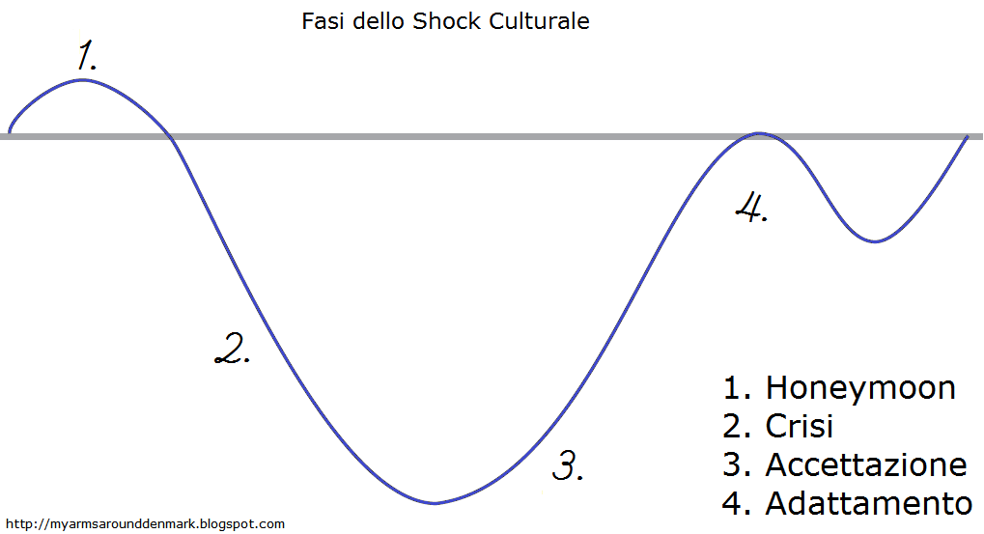

**Honey moon: Everything is wonderful, euphoria, enthusiasm**

**Adaptation**

**Acceptance**

**Crisis: depression …**

Phase 1: **The "honeymoon"** can last from a few days to a few weeks up to a maximum of 6 months. It is characterized by the fascination for novelty, great enthusiasm, openness, curiosity and availability towards the new situation.

Phase 2: **The period of "crisis"** coincides with the onset of problems, experiences and negative reactions. Thoughts begin to be negative, disadvantages stand out more than benefits, and cultural difference becomes irritating. Prejudices, stereotypes and aggression arise.

Phase: 3**:"Recovery / acceptance"** characterized by greater awareness and acceptance of differences. Problem solving by virtue of greater autonomy is sought with courage and patience. We approach the host country through the study of language, knowledge and sharing habits, moving towards a gradual acceptance and tolerance of the new. The individual regains confidence in himself and can take problems with a sense of humour, he is able to feel empathy towards those who belong to the other culture.

Phase 4: **"Adaptation"** not only recognizes the cultural differences of the host country but accepts it as a different and equally valid system of life.

**3. CAUSES OF CULTURAL SHOCK**

1. **Clash of cultures** **within the person himself**: because some important aspects of his culture of origin cannot be valid in the culture of hospitality.

2. **Communication failure**: from the fact that we must speak in a new language and become familiar with a new non-verbal language (gestures, facial expressions, etc.).

3. **Loss of parameters and codes of reference**: because the individual cannot consciously and automatically interpret the signs and codes of the new culture as he does in his original culture.  
4. **Identity crisis**: the person can get to the point of losing the concept of self. The fact that the culture of acceptance is assessed by the original culture means that the individual tends to refuse, even to unconsciously accuse the host culture of the hardship or discomfort that he is going through.

**4. SYMPTOMS OF CULTURAL SHOCK**

* Physical tension / discomfort: insomnia, indigestion etc.
* the fear of rejection
* disorientation
* the feeling of loss
* the feeling of surprise.

**5. HOW TO FACE CULTURAL SHOCK**

* decentralization
* comprehension
* negotiation
* Get information about empathy as a communication strategy
* Get information on the phenomenon of cultural shock
* Accept that all cultures are different
* Analyse one’s culture in its traits and trends
* Discern between stereotypes and generalizations
* Avoid the conditions of recoiling on oneself
* Avoid isolation
* Learn a lot about the host culture
* Know the cultural manifestations of the new culture
* Know the key figures of the new culture
* Become familiar with the traditions, the feasts of the new culture
* Stimulate curiosity by watching movies, videos, photos of the new culture
* Discover aspects of the new culture: values, beliefs, and behaviours
* Avoid comparisons
* Set some goals for the new culture: common points
* Put your own culture back in perspective
* Respect the other even if I do not fully understand it yet
* Draw up a list of perceived differences between the two cultures

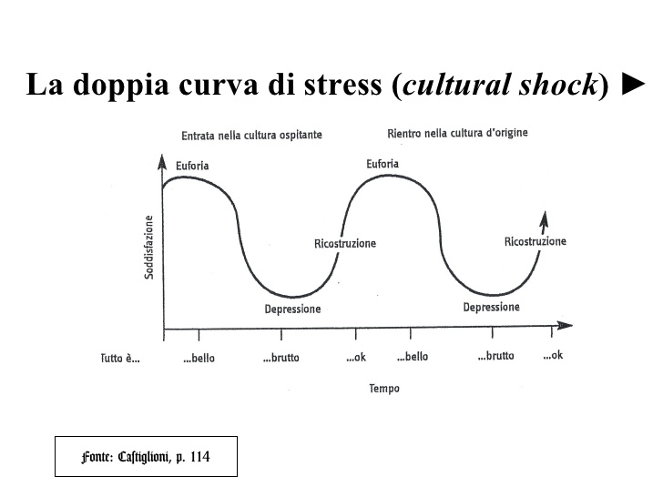

**\* Questions for personal reflection and sharing**

Reread your experience of meeting with a new culture.

1) What was most difficult for you?

2) Can you reconstruct, in your personal experience, the four phases of the cultural shock described above?  
3)What has helped you to overcome the crisis to get to the adaptation phase?  
4)What help have you received from the confreres and the locals?  
5) What would you recommend to those arriving for the first time in a cultural environment different from their own?

**EXERCISES - Cultural Shock**

1. Read the letter from Ahmed, a student on an exchange programme recently arrived in France (based on authentic information)  
2. Identify the phases of the cultural shock experienced by Ahmed. What are the symptoms?  
3. Identify any causes.  
4. Do you think that he is really engaging in a new phase?

*Dear friend,*

*you remember my last letter, when I had just arrived ... "All new and all beautiful". I really liked the new autonomy that my stay here gave me, because in Europe people feel more like individuals than as members of a group and this was super, because it gave you that feeling of great freedom.  
Many small details seemed strange, but quite formidable, for example if you went out for the party, the next day, everyone showed up at school. So I enjoyed myself, but without ever losing my lessons; here it seemed easier to face people, because they are more direct and clear, while from us, according to the context, the protocols are more complex and we need to know how to do it.  
I also told you that it was easy to meet the other students here.*

*Now I'm really disappointed because even if they greet you gently in the morning, after when you go to the cafeteria in between the lessons, you realize that in reality nobody really cares about you. Nobody invites you to his house. If we meet outside the lessons (rarely), it is at the bar ... to go to their home, it must be exceptionally for big occasions (I cannot even say which ones). Yes, it is true that we talk a lot, but everything and nothing ... never something serious, for example, this struck me, religion is almost a taboo subject. People here are not practicing or even atheist. I already knew about this, but looking at it closely, is another thing.*

*It is true that on important topics, I am not able to make big debates. I continue to have great difficulties to express myself and also to understand (imagine, not even with gestures, I'm sure I always understood). Also, I believed that my English would serve as a spare wheel, it all failed because in the public administration they refuse its use and they speak to you as if you knew perfectly their language (what is still far from being a reality). In the end, you do not understand anything, and you never make the right documents. Well, the other day I wanted information by phone .... madness, I fell all the time on an answering machine and I did not understand anything about the instructions ... I tell you it's really frustrating!*

*I confess that for some time I have so much nostalgia and sometimes I'm angry ... I'm working on it, but it does not work ... I think what I would like to do is pack my suitcase and go home. I had a great desire to leave the family, I must admit that today I miss it so much .... Yes, my friend in reality I miss you all (I remember the laughter at the cinema?) And I often feel alone and misunderstood.*

*Besides, I do not see why I have to keep on committing myself, because in reality it does not change much. I wanted to invite a guy who seemed nice to have a coffee in my house and listen to my music with me, it took me a thousand years to reflect before saying no. My companions (it must be said in a hurry) have no curiosity for my culture, and yet I do not stop being interested and adapting to theirs. You're about to say I'm depressed ... but how not to be when you see your so-called friends go home in the car after class and leave the bus stop without saying a word, while we live in the same neighbourhood.  
Please do not say anything to my parents ... I do not want to give them worries ... I still think I'll try to put it all ... it was difficult to get the scholarship and then basically this culture is interesting, and life here has some positive aspects.  
Well, next weekend, I intend to invite a small group for my birthday ... we'll see what happens! I'll let you know.  
  
Your friend Ahmed, with "tears in the eyes", and who of late sleeps very badly and has some digestion problem.  
  
  
NB. Yes, yes, I know what you're thinking ... I was not sufficiently prepared to understand the culture before landing here ... but do not worry, it's never too late to start.*

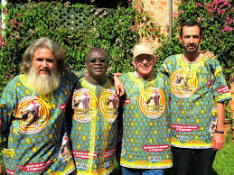

**Chapter 5**

**ENCOUNTERING THE OTHER WHO IS DIFFERENT**

**SENSITIVE AREAS   
of Margalit Cohen-Emerique (1989)**

**I. SENSITIVE AREAS**

The meeting with the other who is different sometimes causes discomfort, restlessness, feeling of revolt that can, in some cases, produce stress and anxiety. These emotions can be aroused by behaviour or by words that affect us in a sensitive area. Each of us has built an identity in which there are more sensitive areas. They are generally formed by events in personal history, family traditions, professional formation, etc. When these areas are touched, a feeling of discomfort is produced in the person.

**EXAMPLES OF SENSITIVE AREAS**

**1) The guiding images**

They are prescriptions of behaviours or attitudes learned and kept in memory. Often, they are not explained or formulated, they seem natural and evident. They are powerful representations, not always conscious but very charged with affectivity because they take root in the cultural foundations of the personality, in its unconscious dimensions such as parental and sexual identifications and concern the education of children, honesty, cleanliness, dirt, care for the sick, ... values.  
  
**2) “*Archaisms”***

They are traditional models of conduct, usually experienced as "problematic" that more or less have been 'overcome', individually or by society in general through collective progress (promotion of women, individual freedom ...). The contact with a "different other" can frontally "put at risk" these acquired results and give the impression of being threatened by regression.  
  
**3) “*Removals”***

They are painful facts experienced by the individual in personal history and stored in his unconscious. They can also be fuelled by prohibitions the awareness of which has been prevented by the family, group or culture. The "return of the removed reality" can be caused by the presence of any other and give rise to emotions and anxiety (taboos).

**4) Historical contests**

They come from conflicting social events that have taken place over time. The facts of history remain in the imagination of the peoples: the crusades, colonization, slavery, Shoah, etc.  
The other can revive those memories, play them consciously or unconsciously, and make you take a share of responsibility for what happened.

**II. THE CRITICAL INCIDENT**

In the interaction with the other-different, when the sensitive areas are touched in an inadequate way, there is the possibility of living or causing critical incidents, intercultural situations in everyday life, characterized by misunderstandings caused or suffered concerning the representation of differences and cultural change. The critical incident can provoke conflicts, or it can become a source of learning and of a new attribution of meaning on the condition of being conveniently analysed.  
  
**Example of a critical accident**

Aldo is in Copenhagen (Denmark) to attend a Danish language course and is a guest of a family that has welcomed him amicably and where he will stay for two weeks.  
On the day of the start of the course, at breakfast, Aldo informs the family that he will finish the lessons at 5.30 pm, he will take the 18.00 bus and dine at home.  
When he gets home, he finds the family in front of the television while he takes a cup of tea.

The 10-year-old son is washing dishes and tells Aldo he can heat his dinner in the microwave. But Aldo remains a bit bad, does not understand why they have not waited.

The intercultural meeting requires:

* To know how to manage one’s emotions
* To suspend judgment and question oneself to understand one’s cultural frame of reference
* To ask for clarification from another by making the effort to understand his cultural frame of reference.

**\* Questions for personal reflection and sharing**

1) Starting from your culture of origin, identify an example corresponding to each of the sensitive areas mentioned.

1. Tell and analyse the experience of a critical incident that happened to you through  
   **the analysis grid of the critical accident**

i. What happened?

ii. What was the emotional reaction you experienced?

iii. Which norms / values ​​/ representations have been touched, threatened, questioned in you?

iv. What image did you make of the other person?

v. What could be the norms / values ​​/ representations of the other person / culture that determined the specific behaviour that caused the experience of cultural shock?  
vi. What lesson can you learn from this experience?



**EXERCISES**

**CRITICAL INCIDENT: “BLOWING ONE’S NOSE”**

*[Compiled by: Élan Interculturel, France, 2012]*

**1. Culture of the person who has experienced a shock**

French woman, about 20 years old, working experience in Korea as a French teacher in a military school. She has already had teaching experiences abroad, particularly in India, in both urban and rural contexts. She loves cultural exchanges and at the time of the testimony she wrote articles for an English newspaper, where she told her experiences of cultural shock while she was in Korea.  
  
**2. Culture of the person who "caused" the shock**

Young students of the military school. The narrator did not have specific information about the students' cultural background (at the time of the testimony), but they seemed to have a great sense of respect for orders, hierarchies and rules. Although the school is mostly frequented by men, a fairly homogeneous number of men and women took part in the French class; the female students seemed to show a lot of interest in the French language.

**3. Description of the event**

I worked as a French teacher in a military school in Korea. It was winter, I was doing my lesson as usual, when I could not help noticing that many of the students were feeling cold and with a runny nose. None of them, however, tried to blow their noses and kept sniffing all the time. It annoyed me a bit and I could not concentrate. Finally, I took out a packet of tissues from my pocket and tried to distribute them to the students. I was amazed when all those who actually needed it refused to take it. So I continued my lesson even if their gesture had a little confused me. Later, I went to the commander (the director of my department) to tell him what had happened. He explained that in Korea, it is considered rude to blow one’s nose in public. I was very ashamed when I was able to finally understand the reaction of my students.

**4. Emotional reaction**

When the students refused to blow their noses, I was very annoyed, believing that their behaviour was rude. After this initial reaction, I simply thought that they did not have handkerchiefs with them, so I considered it appropriate to take out a packet of tissues from my bag and offer it to them, solving the problem. But when they refused, I felt confused and a little embarrassed. However, after talking to my boss and understanding why they had refused, I felt even more embarrassed.

**5. Which norms / values / representations were touched / threatened / questioned in the narrator?  
Hygiene:** For the narrator, a runny nose can contribute to the spread of diseases. Her gesture of offering a tissue was simply a discreet way to help them wipe their noses. Not only did the young woman feel irritated but also slightly disgusted.  
**Good manners / education**: Besides being a hygienic question, blowing your nose in public is considered an appropriate gesture in French culture. It allows the person suffering from cold to solve his nose problem, so he can continue doing what he was doing.

**6. What image did you have of the other person?**Slightly negative. In the beginning the narrator was irritated by the behaviour of her students.  
  
**7. What norms / values / representations of the other person / culture determined that specific behaviour? (Hypothesis)**  
In Korea, as the narrator has subsequently learned from her boss, blowing one’s nose in public is to be considered an unkind gesture. So, if in the perception of the narrator the behaviour of her students is seen as vulgar, equally vulgar is for students to blow their noses in a context like that of the class. This code of behaviour can only be understood if one considers that for them all the natural functions of the body must be excluded from the public sphere. Blowing your nose in public could be seen by the Koreans as a way to attract, at that moment, the attention on oneself, rather than a way to wipe one’s nose discreetly. Ignoring the runny nose while in public and continuing to sniff is more appropriate for them than to use a tissue, which will then be used in private.  
  
**8. What did you learn from this experience?**The experience in question led the narrator to question certain cultural parameters that have always appeared "natural" to them. See applied, in a simple situation like that of blowing one’s nose, a code of behaviour / hygiene different from one’s own, made her understand how her notions of hygiene are culturally influenced. For her future teaching experience, she understood how important it is not to impose herself on her students, not to force them to make gestures that seem simple to her or of little importance, to try to adapt to the new cultural context so as not to offend people with whom she is working and relating to.  
  
  
**\* What are your comments and reflections in the light of what was presented in the critical incident: "BLOWING ONE’S NOSE"?**

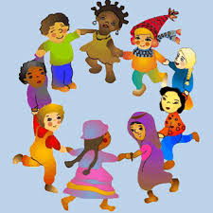

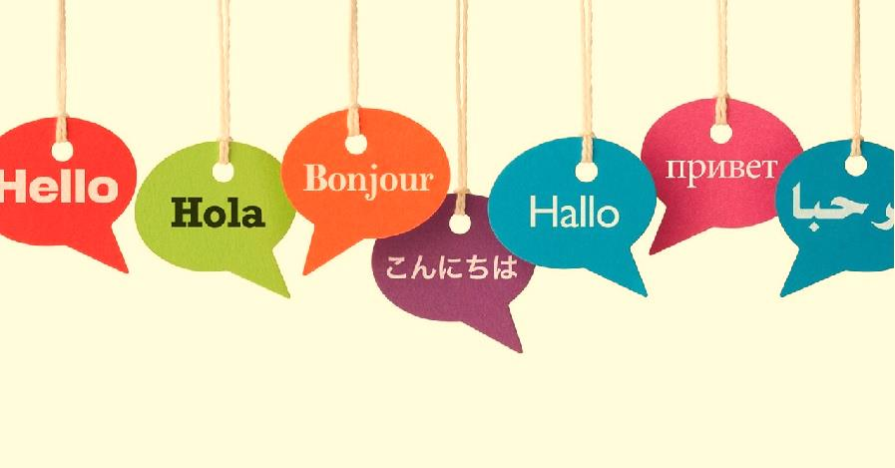

**Chapter 6**

**INTERCULTURAL COMMUNICATION**

**According to Paolo Balboni**

**Introduction**

Difficulties of approach between people with different cultures are mitigated by carefully evaluating three elements:

1. Fundamental cultural values, such as: the family, social relations, basic concepts, hierarchical structure  
2. Non-verbal communication and therefore the greater or lesser weight given to gestures, the very meaning of gestures, facial expressions, clothing, the distance between bodies  
3. Verbal communication, such as tone, pauses and rhythm of the voice, the choice of words, the construction of the sentence.

To the very same word or behaviour, people of different cultures give different meanings, for example:

* the family, the hierarchy, status, time, the relationship between private and public, finance
* sitting cross-legged, the space between people, physical contact, kissing, the tone of voice,

**IN INTERCULTURAL COMMUNICATION  
1) The language can be:  
Direct**: We talk a lot, we give the maximum information. Direct language is typical of rules, laws, techniques, employment patterns  
  
**Indirect:** we speak little, and others must guess the rest (typical in communication between friends). Non-verbal language, rituals, rules of good manners, etc. are privileged.  
  
**Explicit:**

* the interrelationship is direct, the approach is linear
* we speak clearly, in no uncertain terms
* show your disapproval
* to conclude a deal, to put an agreement together, everything is written
* we talk to each other face to face
* the communication is rational
* behaviour and appreciation depend on the personality.
* the facts are what matters
* conflicts are dealt with explicitly and quickly
* one’s emotions are not shown

**Implicit:**

* in an indirect way the harmony in the relationship and prestige are nourished
* asks without asking, implicitly
* indirect communication is used with an intermediary
* language is more emotional
* behaviour and appreciation depend on the role
* honour is more important than facts
* conflicts are avoided
* they show their emotions.

**4. Contextuality can be:**

**High**: when a message exchanged contains very few factual information, we must find a meaning in the relationship or in the personality of both partners  
**Low**: when there is a strong distinction between private life and professional life, more information must be given in communication  
  
The differences of high or low context can generate misunderstandings.  
**High:** someone of a culture of high contextuality can consider the other culture as chatty or too direct.  
**Low**: inversely, someone of a culture of low contextuality can consider the other culture as suspicious, doubtful (I hide information) and therefore not cooperative.

**5. The concept of time can be:  
Monochromic:** time is considered a resource to be managed; the tasks are divided into sub-sections to be treated one by one according to a set plan  
**Polychromic**: the different activities are managed in the available time and are interrupted as often as necessary. It is possible to have several priorities at a time.  
  
**6. The body-language in different cultures**  
Communication experts remind us that a message is made up of: 7% content, 55% mimicry and gestures, 38% intonation. Non-verbal communication is very important and is even more important in intercultural communication when there is no common language.  
Non-verbal communication consists of different elements: distance, physical contact, facial expressions, mimicry and gestures, physical posture, silence, ...  
It is very important to know the body language of the cultures in which we live because the interpretation of behaviours is very different according to the cultures.  
It is impossible to know all the non-verbal signs of every culture, there are about 70,000 in the world. The capacity and the desire for synchronization are important, that is to adapt to the other, to the group, to become close.  
  
**\* Questions for personal reflection and sharing  
1) Your culture:**

* Is it inclined to direct and explicit language or to indirect and implicit language?
* Is it rather high or low contextuality?
* Do you tend to be monochromic or polychromic?

2) List some non-verbal communications specific to your culture of origin  
3) Do you remember some experiences of misunderstanding due to the non-verbal communication of the culture you knew in your mission experience, when you were not familiar yet?  
4) How is physical contact is lived in your culture of origin and by some confrere of another culture

with whom you lived in community?

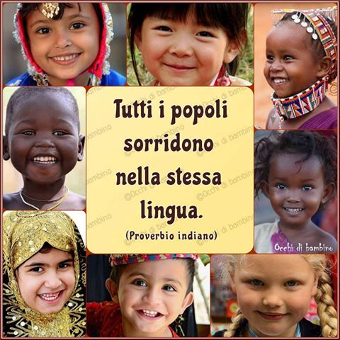

**Chapter 7**

**PREJUDICES AND STEREOTYPES**

**INTRODUCTION**

Prejudice is an opinion that we formulate *a priori* without having any evidence, not documented. It can be positive, but in general it is negative. The prejudice linked to the races is the most common; we use it to simplify reality.

A stereotype is a model, a simplification of reality, with which we claim to describe the members of a human group or a category of people. Stereotypes inevitably lead to something negative.  
Allport is none who has deeply studied prejudices and their nature, and he defined them as "thinking badly of others without sufficient reason". This definition contains the two essential elements: referring to an unfounded judgment and its negative value.

Many times, we form prejudices towards people, for example due to the first impression of sympathy-dislike.  
The most recurrent and heavy are related to discrimination and racism (for example, the movie "*Guess who's coming to dinner*").

**1. HOW PREJUDICES ARE FORMED**Education can influence the formation of prejudices, which are learned in the first place in the family. Children are not born with prejudices but are mainly induced by their families. Children imitate parents and if they see discrimination actions, they imitate them. Most prejudices are learned in pre-school age but can be overcome later with experience.  
Prejudices in addition to family education are influenced by the social group to which one belongs and by the competition between groups. The authoritarian and rigid personality is more susceptible to prejudice because of its need for rules to be respected.  
  
**2. THE CONSEQUENCES OF PREJUDICE**Discrimination: people belonging to another group are treated differently. If we avoid, criticize, despise certain people, they can diminish their self-esteem, change the concept of self, they can become completely devalued.  
This can lead to a reduction in commitment, changes and motivation are reduced, prophecies come true when we act on others based on what we expect from them; this leads to social isolation, a social difficulty to relate to others, an ever-increasing closure and a difficulty in relating to others.  
  
**3. HOW TO OVERCOME PREGUDIES**

* Distinguish the individual from his group of belonging, avoiding generalizations
* Accept cultural diversity and points of view
* Look for explanations different from the preconceived ones
* To create contacts between people at different social levels, to interact in order to see positive aspects in others
* Prejudice is eliminated if the social classes are more or less equivalent, otherwise the prejudices remain.
* To overcome stereotypes and prejudices it is necessary to decentralize, that is, to leave the traditional reference frameworks.

**"We must learn to live together as brothers  
otherwise we would die together as idiots. "  
(Martin Luther King)**

**\* Questions for personal reflection and sharing**1) List some prejudices or stereotypes of which you have suffered in the relationship with the confreres in your community because of your culture.  
2) Remember some prejudices or stereotypes that you had or that you have towards the confreres of other cultures or towards the people where you have carried out your mission.  
3) Have you had any positive experience of overcoming prejudices or stereotypes of which you were a victim or that you had towards people of other cultures?  
4) What can you do concretely to overcome the prejudices present in our communities?

**EXERCISES - Stereotypes and prejudices**

*in https://seieditrice.com/vivere-insieme/files/2013/02/13_stereotipi_pregiudizi.pdf*

1. Read the story *A trip to Italy*, which tells how a foreign child, in this case a Chinese, sees the Italians.
2. What are your prejudices? How do you interpret the actions, the gestures, the ways, which idea does he have of Italian society?
3. What are the most common prejudices and stereotypes of your culture or of your mission context? How did you internalize them?

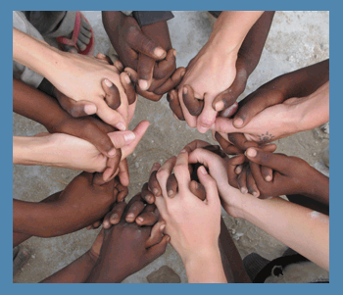

***A trip to Italy***

*I went to Italy with my dad and his friends. It's the first time I have come out of China. The outside world is very different. The teacher says that those people are more underdeveloped than us and we Chinese are better. I've seen that they really are not as good there as we are.  
Italy is a very great country. It's all in the mountains. From the plane they are beautiful. We arrived at the airport. Dad told me to pay attention to the suitcases because it was dangerous. I was careful, but they stole the wallet of a friend of my father. He called a policeman. This did not understand neither Chinese nor English and I do not know what they said to each other.  
A gentleman was waiting for us in a minibus. He took us to the city of the meeting (the city of twinning, not specified). It was very far. The head of the city was waiting for us in front of his palace. He had a nice elegant dress, but he had put on a red and green coloured band that made one laugh. I believe they are the colours of his tribe. Behind him there were two soldiers dressed in white, wearing a helmet. One carried a small flag on a plastic pole.  
The inhabitants of that country are still primitive. Instead of bowing, the head of the city took my dad's hand and held it tightly. I think it's a sign of power, because others have done the same, but with less force. Everyone touched me, the head, the cheek, the hand. Perhaps they had never seen a yellow child. When dad said we were from Ningpo, nobody knew where it was. The head of the city said that he knew it. There they only know Beijing and Shanghai.  
A gentleman had a map of the world. It was all wrong, because China was on one side and not in the way it really is. Dad did not say anything not to offend them.  
We went for lunch. In that country they are not civilised, and they do not know how to use sticks. They do not cut food in the kitchen, but everyone has a knife and cuts things on his plate. We did as they do, because dad says that we should not offend them. Not everyone has the bowl for rice, but a basket of bread in common for everyone. Everyone takes it with their hands. They do not drink tea but only water and lots of wine. The food was good, but dad told me not to take the salad because they eat it raw there and we can get sick. The next day I saw something very strange: all the shops were closed. The head of the village came to the hotel. He asked us if we wanted to see a religious ceremony. We went to a big church. People were all dressed well. Dad says that on that day they put on the most beautiful suit they have. In front there was an old man in a long, white and green dress, who gave orders, and everyone got up, sat down, knelt down. There was also music. Then everyone has to give money then to queue and take a small piece of bread. They do not give it to foreigners, so we remained seated.*

*After that we went to sleep. I was very tired. The day after, dad was invited to an assembly of that village. I went with him. They made many speeches in Italian. Nobody can speak Chinese. There was no order in talking. Sometimes a young man spoke before an old man, or a woman spoke before a man. A man sitting near dad translated everything. Dad told me that the head of the village is chosen by counting everyone's votes. The vote of women is worth that of men, and the vote of a powerful person is the same as that of a poor man. It seems to me that this is like telling a student to be a teacher. In China it is much better. In the afternoon I went to visit a museum, but I was tired, and I slept. After another of their lunches, dad went to a meeting. Some gentlemen brought me to the mountains. It was wonderful. They have no factories and the air is clean! In Italy they are all shepherds. Every family has goats, and a dog. I hope that when Chinese civilization arrives here, it will not destroy those beautiful places.*

**N.B.: If we want to go beyond stereotypes and prejudices, we have only one chance: to know and meet the other. We have to meet him, listen to him, understand him and accept him. We will not always agree with him, we will not always be able to fully understand his way of thinking, but if we try, we will feel richer, freer and happier.**

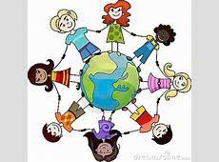

**Chapter 8**

**THE THREE LEVELS OF INTERCULTURAL RELATIONSHIP:**

**INTERPERSONAL, INTERCULTURAL**

**AND INTER-RELATIONAL**

**INTRODUCTION**

**1) For an intercultural approach the theoretical knowledge of the other is not enough**The path to discovering the other is too often influenced by stereotypes, for example: "All Brazilians love carnival and football." Often spontaneously projecting on an individual or a group the scant knowledge of their culture, without taking into account the unique character of the person.  
  
**2) When the diversity of the other threatens us in our own identity**This projection takes place especially when one feels struck / threatened in one's identity, and reacts emotionally, replicating, perhaps aggressively, and reaffirming the false images that one has of the other. Conflict is then inevitable. Thus, the approach that is limited to disseminating information about the stranger is insufficient: the accent must be placed on the relationship between me and the other.  
  
**3) The intercultural meeting is between people**Generally, it is believed that the intercultural encounter is between cultures and national identities. In reality, people come into contact with people who are carriers of different cultures.  
  
**1. THE INTERCULTURAL RELATIONSHIP IS PLAYED AT THREE LEVELS**

1) Interpersonal, where the personal and social identity of the individual interact  
2) Intercultural, where cultural differences occur between individuals in interaction  
3) Inter-relational / meta-communication that allows reflection on the ongoing relationship.

**2. THE THREE PHASES OF THE INTERCULTURAL APPROACH**Each of which is based on different formation methods and tools, based on the development of different skills:

1) Decentralization - in reference to myself  
2) Understanding of the other - in reference to the other  
3) Negotiation - with reference to the relationship.

**1) Decentralization**It is based on the recognition that if there is a conflict it is not only the consequence of the other culturally different, but rather the interaction between two different cultural reference frameworks. Decentralization therefore invites us to explore the involvement of the models, practices and cultural norms - and even professional - of the individual and the way in which they interact with the values/norms/expectations of the other.  
  
**a. Decentralization to avoid distorting the perception of the other**It is the first step in that it springs from the observation that our cultural reference frameworks act as filters - as if they were glasses - influencing the way we see the outside world. Decentralization makes it possible to lift these glasses enough to be able to see their colour and shape, and thus better understand how we filter our perception of others.  
  
**b. Decentralization - awareness and self-perception**Decentralization involves the acquisition of tools to facilitate awareness and self-perception. It enables us to take a step back from a potentially delicate situation and try to resist the urge to immediately seek an answer and a judgment on the other: “*How can they oppress women by forcing them to hide their faces and their shapes?"* And instead, pay attention to ourselves "*Why is it important for me to choose the way I want to dress? Why is it important for women to show their faces and their shapes? ".*

**2) Understanding**Once we have become aware of our norms, values, cultural patterns, we are ready to open our eyes to others. The objectives of this phase:  
1) To acquire an idea more corresponding to reality on the values, norms, cultural schemes of people of other cultures, which goes beyond simplistic assessments and stereotypes  
2) Become aware of the multitude of factors that can influence the cultural frame of reference of the other.  
  
**Key skills for understanding the other's frame of reference**1) Daring to be curious to challenge each other when a behaviour / a rule that seems strange to us emerges...  
2) Carefully observe behaviours and reactions different from what seems normal (for example being able to notice in Japan the absence of the handshake as a typical greeting ritual)  
3) Connect the observations in a systemic way to our wealth of knowledge and practices (for example, broaden our representations of what can be a greeting ritual slowly learning the slight nuances of the bow).

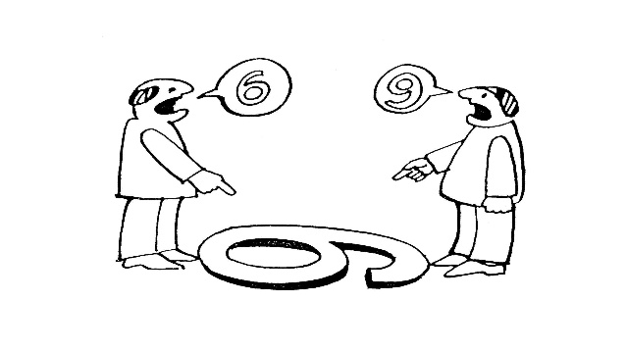

**3) Negotiation / Mediation**It implies finding a solution to a concrete problem in order to respect the identities of both parties as much as possible. The attitudes and skills to be developed to improve our negotiation:  
1) Active listening and non-violent communication: listening to others, not focusing only on what we want to achieve and where our reserve line is.  
2) Resistance to the tendency to close: avoid the impulse to close communication and end the relationship in an emotionally demanding and threatening situation.  
3) The awareness of non-verbal communication, ours and that of others.  
4) The ability to move between personal and professional spheres to maintain the relationship: when there is a block in the process, it is realized that the transition between professional and personal status can become a resource to maintain the connection.  
5) When there is a conflict, situate ourselves at the level of values, that is, the attribution of meaning, for a different interpretation / interpretation of reality.  
6) Recognizing the other as an indispensable interlocutor, for this reason every personal attack must be eliminated.  
7) Do not hesitate to declare your own non-knowledge of the cultural specificities of the other and ask for information to leave nothing implicit.  
  
**CONCLUSION**: **Interculturality is an experience of permanent change**  
It is another aspect to underline: nothing is given once and for all. The person is dynamic and bears a dimension of elusive mystery. Often the questions remain suspended and it is simply necessary to accept that there is not always the answer. To continue the process satisfactorily, the person must be able to question himself constantly.  
  
**\* Questions for personal reflection and sharing**1) Describe the experience of a conflict that arose due to the lack of decentralization on your part  
2) In your community experience you can remember a positive experience of dialogue / communication that has made possible a mutual understanding of cultural differences.  
3) From your experience what hinders and what can help the search for a solution to a concrete problem that respects as much as possible the different cultural identities that interact?

**Chapter 9**

**MULTICULTURAL IDENTITIES**

**IN MULTIETHNIC RELIGIOUS COMUNITIES**

**INTRODUCTION**

Many people maintain a basic contact with their own culture of belonging, with its values, traditions, customs and social rules and at the same time can be identified with a new culture, that of the place where they are located. In this way individuals continue to carry within themselves cultural values ​​beliefs that guide their thoughts and their affections, even if outwardly there can be an apparent adaptation to the expectations of the dominant cultural group.  
What seems natural in a culture can influence the way we evaluate ourselves and others. This often happens in multicultural religious communities.  
  
**1. THE IDENTITY CONFUSED IN THE RELIGIOUS COMMUNITY**Many times in inter-ethnic religious communities, people from different nationalities find themselves experiencing a profound cultural disorientation, because on the one hand they are invaded by the cultural messages foreign to them, the dominant group or the place where they live, on the other they bring with them deeply rooted cultural models, but which fail to integrate positively with the models of culture in which they are located.  
The impact with the novelty of the culturally different environment from one’s own disorients the individual and provokes a "confusion of identity", to which it is difficult to give adequate answers. The most visible consequences of this confusion are: a dangerous sense of alienation and uprooting during the adaptation phase, the absence of cultural certainty and guidelines for managing oneself in life and for integrating experiences.  
The person of a culture other than the dominant one can incur the risk of feeling marginalized if he / she cannot recognize his / her own cultural models as valid for orientation in the new environment, and if he / she lives the relationship with the host culture with a competitive perspective  
  
**Example of an Asian religious in a community of English culture**An Asian religious who arrives in a religious community where people are of English nationality. The patterns of reference of the organization of that community will naturally be set according to the dominant culture in that context, that is English, so that the adaptation messages that are sent to the confrere coming from the East will be set in such a way that he can do according to the normal English style of eating, greeting, praying, welcoming, talking.  
So far nothing strange. The psychological mechanisms of confusion are triggered when the burden of information coming from the dominant English culture is not metabolized together with the cultural model that the confrere naturally brings with him.  
Although outwardly he will be able to show a discrete adaptation (functional to a defensive process to avoid a painful and frustrating marginalization), on the other hand he risks confusing his own cultural identity between his own culture and that of his host. The consequences can be multiple. He can adapt by pretending to ...  
Or he can reach a saturation point of his own adaptation, and then begin to systematically reject the English cultural model, or he can alternate moments of adaptation (for example within the community) to moments in which he expresses his expectations or his cultural needs outside the control of the community (for example when it is outside the community)

1. **ACCULTURATION STRESS**

The risk of living one's own culture of origin as "irrelevant" and so “to be forgotten” leads the person to disregard the cornerstones possessed in his own culture, without having integrated the new cultural orientations proposed, with a consequent loss of the emotional reference and ideological points that the local culture would provide to the person.  
The distancing from the local culture causes stress from acculturation, especially if acculturation is not voluntary. This stress increases with increasing distance between one's own culture and the culture in which one is welcomed. This can be a source of significant discoveries until it reaches true personality structures that develop in parallel without integrating into sufficiently functional levels.   
  
**3. THE CHALLENGE OF MULTIETHNIC RELIGIOUS COMMUNITIES**The phenomenon of multiculturalism in religious communities is becoming more widespread, which produces extensive contacts between cultures and subcultures with a rapidity never experienced so extensively.  
Hence the importance of mediating between the different cultural models, this means getting in touch with different cultures, knowing them, loving them and comparing them. It also means allowing oneself to know and love one's own culture, in order to allow the other a proactive interrelationship in the sense of reciprocity.  
The challenge is to:

* integrate diversity into a unity that is not an indistinct flattening or a passive conformism, but a permanent reconstruction of the common platform, consolidated by the awareness of the cultural resources of the brother and supported by shared objectives
* avoid the homogenization, isolation, disintegration of one's self
* harmonize the values ​​of human coexistence in a privileged context for an effective experience of communion, such as the religious community.

**4. THE RECIPROCAL RELATIONAL EXPLORATION**The integration of different cultures in the same community is a process of reciprocal relational exploration that helps to get to know one another better to understand how to integrate cultural and personal diversity towards fraternity and co-responsibility.  
In the mutual relationship, people have a double task that concerns their own and others’ identity: maintaining a firm sense of the original cultural traditions and, at the same time, incorporating a number of behavioural values ​​and norms of the culture of the majority sufficient for the members of that group to feel and behave like members of that culture.  
The distinctive feature of integration is therefore a bicultural sense of self, which interweaves the unique characteristics of the two cultural groups.  
  
**\* Questions for personal reflection and sharing**1) Acculturation stress, confusion of identity: you can share some personal experience or of confreres with whom you have lived  
2) If in your initial formation you have had formators of a culture that is not yours, what was your experience? Difficulties encountered and positive aspects that you remember  
3) If you belong to a minority group in our Congregation, what was your experience of living together with confreres belonging to the dominant culture?

PROCESSING  
OF COMMUNITY COMMITMENT  
TO GROW IN MULTICULTURAL COMPETENCE

Because our multi-ethnic communities are a sign of the Kingdom according to the Comboni charism

As announced in the introduction, this Handbook ends with the invitation to process, at the end of the workshop, a community commitment to grow in inter-cultural competence. This community commitment takes up the community-based commitment (or in a group) at the end of each sharing.  
  
This commitment should have the following characteristics:

* simplicity
* clarity and concreteness
* realistic realism
* indicate attitudes to be taken and initiatives to be lived as a community

The fundamental attitude required is to get involved and the determination of everyone to assume what is decided together.

APPENDICES

1. **MOLECULE OF CUTURAL IDENTITY**

**Source**: ANNONCER la couleur, *Vivre ensemble autrement – guide pédagogique*, p. 13.   
Adapted for our formation

*Most common stereotypes and prejudices*

*of your context of life*

*Sensitive areas of your culture*

*Some salient aspects of your culture and how you have interiorized them*

*Remember a critical incident  
that you have experienced*and make a rereading starting  
from the studied grid.

*Peculiar elements*

*of communication*

*of your culture.*

*Aspects to be boosted up and improved.*

*Re-read your experience  
of cultural shock and identify  
the different phases  
and what helped you  
to overcome the crisis to get to adaptation*

**2. INTERCULTURAL COMPETENCE: SELF-EVALUTATION**

1. The elements listed below are invaluable in the development of intercultural competence and in effective and appropriate interaction with people from other cultures. Please rate yourself on the following:

5 = very high 4 = high 3 = average 2 = below average 1 = poor

|  |  |  |  |  |  |
| --- | --- | --- | --- | --- | --- |
|  | 5 | 4 | 3 | 2 | 1 |
| 1. Respect (appreciating the other culture) |  |  |  |  |  |
| 1. Openness (to intercultural learning and to persons of other cultures) |  |  |  |  |  |
| 1. Tolerating ambiguity |  |  |  |  |  |
| 1. Flexibility (in the use of appropriate communicating styles and behaviour in intercultural situations) |  |  |  |  |  |
| 1. Curiosity and discovery |  |  |  |  |  |
| 1. Suspension of judgement |  |  |  |  |  |
| 1. Cultural awareness / understanding |  |  |  |  |  |
| 1. Understanding the world-views of others |  |  |  |  |  |
| 1. Specific knowledge of culture |  |  |  |  |  |
| 1. Sociolinguistic awareness (knowledge of the use of other languages in social contexts) |  |  |  |  |  |
| 1. Capacity to listen, observe and interpret |  |  |  |  |  |
| 1. Capacity to analyse, evaluate and to relate |  |  |  |  |  |
| 1. Empathy |  |  |  |  |  |
| 1. Adaptability (to different styles of communication and behaviour; acclimatising to new cultural environments) |  |  |  |  |  |
| 1. Communicative ability (appropriate and efficacious communication in intercultural contexts) |  |  |  |  |  |

1. Reflect on situations that require intercultural competence: what has helped you to make yourself more appropriate and effective in your interactions?
2. Now consider how you can continue to develop your intercultural competence, especially the areas you voted as inferior. (You can write your reflections on the back of this document if it's useful).

**3. COMPONENTS OF INTERCULTURAL COMPETENCE**

|  |  |  |  |
| --- | --- | --- | --- |
|  | | | |
| *Attitudes* | *Knowledge* | *Ability* | *Behaviours* |
| 1. Respect 2. Curiosity 3. Desire to learn 4. Openness 5. Attitude to suspend judgement 6. Attitude to tolerate ambiguity and appreciate cultural diversity | * Knowledge of the culture * Knowledge of the dynamics of interaction between cultures, societies, and individuals * Awareness of one’s own cultural belonging and communication…. | * Listening, interaction * Adaptation * Linguistic sociolinguistic communication capacity * Conflict management * Intermediary in the exchange * Find information * Interpret cultures and put them in relation * Empathy * Cognitive flexibility * Capacity to evaluate points of view, practices and cultural products, including those of one’s own culture in a critical way | * Behave and communicate effectively and correctly in intercultural encounters * Flexibility in cultural behaviour * Flexibility in behaviour of communication * Orientation towards action in view of reducing prejudices, discrimination and conflict. |

**4. MODEL OF INTERCULTURAL COMPETENCE**

**(Deardorff, 2006, 2009)**

The process that goes from the individual level (attitudes, knowledge / understanding and skills) to the level of interaction (desired results).  
The degree of intercultural competence depends on the level of acquisition of attitudes, knowledge / understanding and skills

Individual

**Attitudes**

* Respect (appreciating other cultures);
* Openness (controlling judgement);
* Curiosity and discovery (tolerating ambiguity)

**Knowledge and understanding**

* Cultural awareness;
* Deep understanding and knowledge of culture
* Sociolinguistic awareness.

**Ability**

* To listen,
* To observe and interpret,
* To analyse, evaluate and relate

**Desired esternal result**

* Effective and appropriate behaviour and communication in an intercultural situation

**Desired internal result**

Reference frame (informed / movement of the filter)

* Adaptability,
* Flexibility
* Ethno-relative vision
* Empathy

Interaction

**5. CULTURAL DIMENSIONS – SOME MODELS**

1. **MODEL OF THE ICEBERG**

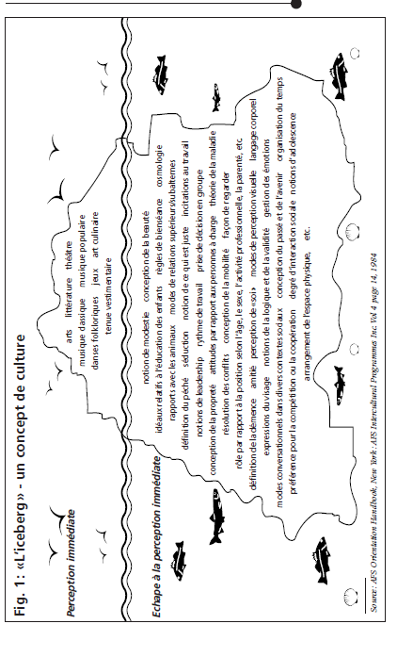

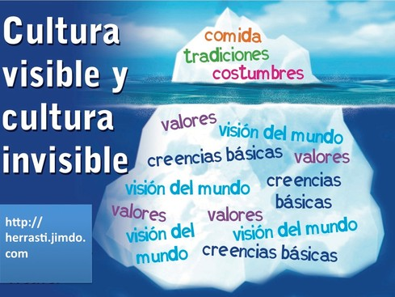

1. **THE CULTURAL DIMENSIONS OF GEERT HOFSTEDE**
2. **Distance from power**

|  |  |
| --- | --- |
| **Elevated distance of power**  Prefers hierarchical bureaucracies, strong leaders and has a very high respect for authority; the leaders are feared and respected and tend to have a paternalistic or authoritarian style, subordinates tend not to question the demands made to them. | **Low distance of power**  Tends to favour personal responsibility and autonomy; the same leaders tend to use more collaborative styles for consultation and participation. |

1. **Individualism / collectivism**

**Collectivism**: the individual grows within cohesive, numerous and protective groups, in exchange mainly of loyalty to the group. The group's needs and mechanisms prevail over individual ones.

**Individualism:** the free will and initiative of the individual are accepted and are engines of development or change**.**

1. **Masculinity/feminility**

|  |  |
| --- | --- |
| Masculinity   * emphasizes status, roles, career * ambition and need for excellence * fight to resolve conflicts, the strongest wins * lives to work * in the world of work, the norm is fairness, competition and performance * sympathy for the strong * spirit of decision | Feminility   * centrality of relationships * attention to the quality of life * negotiation in conflict resolution * work for life * in work, the norm is equality, solidarity, quality of life * sympathy for the weak * intuition |

1. **Control over uncertainty**

|  |  |
| --- | --- |
| High   * a lot of stress, feelings of anxiety * it is possible to express emotions and aggression * emotional need to work a lot and always * the different is dangerous * emotional need for even ineffective rules | Low   * little stress, feelings of well-being * emotions and aggressiveness must be concealed * happy with rest, hard work is not a virtue * the different is curious * less possible rules |

1. **Long-term orientation / Short-term orientation**

|  |  |
| --- | --- |
| Long-term   * there is no absolute truth * perseverance * will to obtain results even with great sacrifices | Short-term   * absolute truth * personal rigor and stability * protection of your image * respect for traditions * reciprocity in moments of gratification, gifts, etc. |

**3) CULTURAL DIMENSION AND THE STUDIES OF FONS TROMPENAARS**

**4) MODEL OF THE DEVELOPMENT OF INTERCULTURAL SENSIIVITY**

**of Milton J. Bennett**

**ETHNO-RELATIVISM**

|  |  |
| --- | --- |
| **Integration** | "Interiorization of different perspectives": "*I live the time differently" "I have a different sense of family".* |
| **Adaptation** | "Change paradigms and behaviour": *"I do not take it anymore if you are not punctual", "gesticulate more"* |
| **Acceptance** | "Respect for differences (behaviours and values)" *" this historical perspective is interesting " "I acknowledge the value of aesthetics"* |
| **Minimization** | "Universalism": "*local uses change but we are all the same" we are all motivated by the same things "* |
| **Defence** | Denigration-superiority: *"visiting other countries is good for me but just to realize how much better mine is, they do not really know how to dress, eat, clean, wash etc.* |
| **Negation** | Isolation - separation: *"as long as we speak the*  *same language ", " all the Capitals are the same: cars, shops, .. "* |

**ETHNO**

**RELATIVISM**

**ETHNO**

**CENTRIC**

**ETHNOCENTRISM**

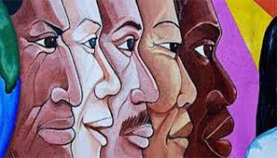

1. **BODY LANGUAGE IN DIFFERENT CULTURES**





**1. THE MEANING OF PHYSICAL DISTANCE**

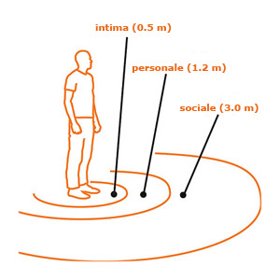

The four principal interpersonal distances according to Hall

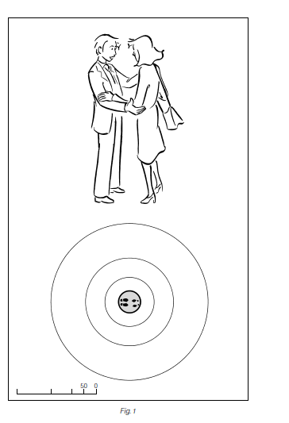

**1. The area of intimate distance (from 0 to 50 cm)**

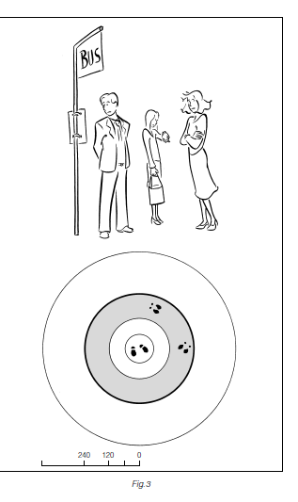

**2. The area of personal distance (from 50 to 150 cm)**

This area is open to the most trusted acquaintances

and friends.

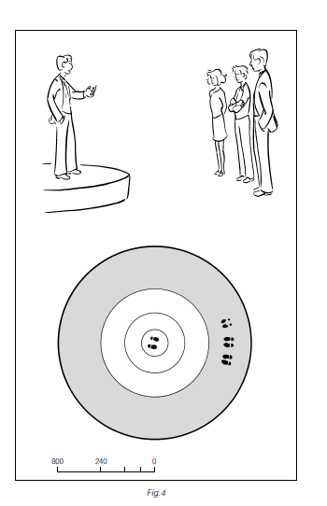

**3. The area of social distance (from 150 to 350 cm)**

This area is linked to interpersonal relationships,

to employment relationships or occasional meetings.

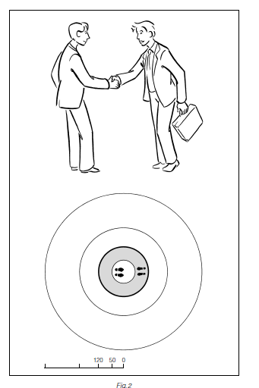

**4. The area of public distance (beyond 350 cm)**

It is the appropriate distance for formal meetings

(typical for example of important characters).

**2. GREETINGS IN DIFFERENT CULTURES**



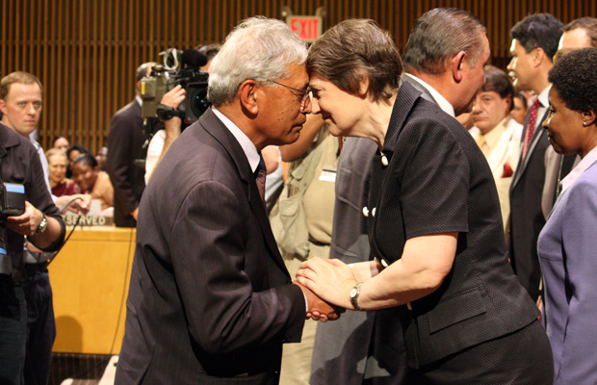

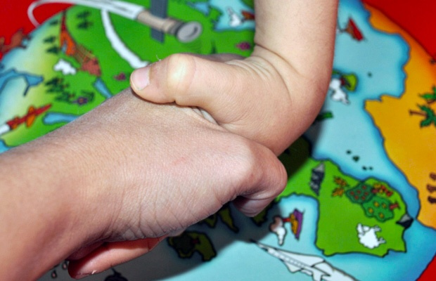

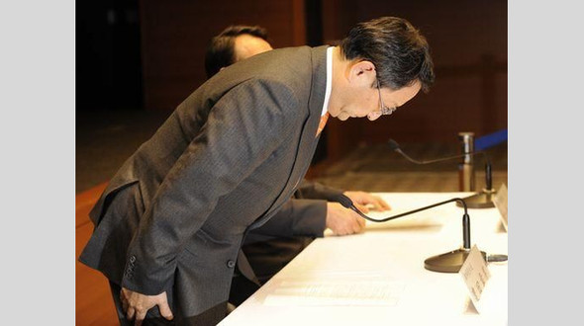

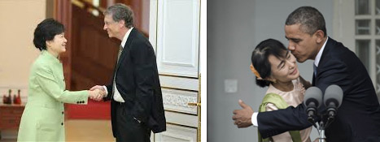

**3. INTERCULTURAL COMMUNICATION**

**AND COMUNICATIVE APPROACH of Paolo Balboni**

