Suggestions for VIVAT Ecological Life Style Check List
Add the points which fit to your situation!

In the House
- Do not use single-use products, especially plastic.
- For daily use of plastic bags, use biodegradable ones.
- Shut off lights, PC, TVs and appliances when not in use.
- Unplug cell phone and laptop chargers when not in use.
- Reduce, reuse, recycle for a less wasteful life style.
- Put the electricity, water, gas bills etc. on the bulletin board of your community.
- Print only when necessary. Print on both sides of the paper.
- Adjust your thermostat lower in winter, and your air conditioner higher in summer.
- Donate or recycle used clothing or appliances.
- Keep curtains closed at night to cut down on heat loss.
- Install solar panels for electricity or hot water.
- Get yourself removed from catalog and junk mailing lists.

In the Kitchen, Bathroom & Laundry
- Install a fuel-efficient stove where people use fire wood.
- Shut off the tap while brushing your teeth.
- Collect water from laundry to clean floors and flush toilet.
- Bring your water bottle, do not buy bottled water.
- Filter tap water for drinking.
- Use the microwave instead of the oven.
- Use bio-friendly soaps and cleaners.
- Wash laundry in cold water. Only run full loads.
- Keep the dryer filter clean. Hang clothes to dry if possible.

In the Yard
- Plant trees and vegetables.
- Collect rain water to use for watering the garden.
- Use compost and natural fertilizers instead of yard chemicals.

At the Store
- Do not get plastic bags. Bring your own bag.
- Purchase locally made products whenever possible.
- Buy items that are made from recycled materials.
- Buy fair trade, sustainable products. (see below)

On the Road
- Walk or ride a bike for short journeys.
- Use public transportation.
- Keep your tires properly inflated.
- Drive a high mileage or hybrid vehicle.
- Take direct flights instead of connecting flights if possible.
- When traveling, turn down your thermostat and water heater.

Social life
- Participate in elections.

This list was made in reference to “The monthly Checklist” by SMEAD.
For more information, visit: https://www.un.org/sustainabledevelopment/takeaction/
Fair trade, sustainable products logos:
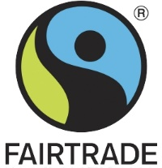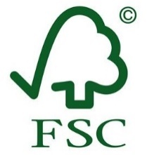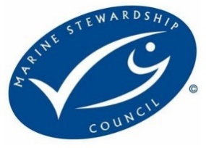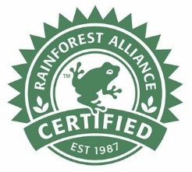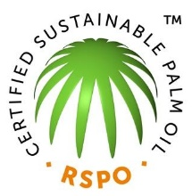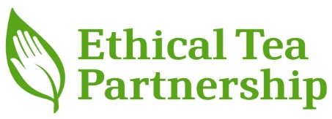
For more information, visit: http://www.ecolabelindex.com/

