ANNIVERSARIOS 2016

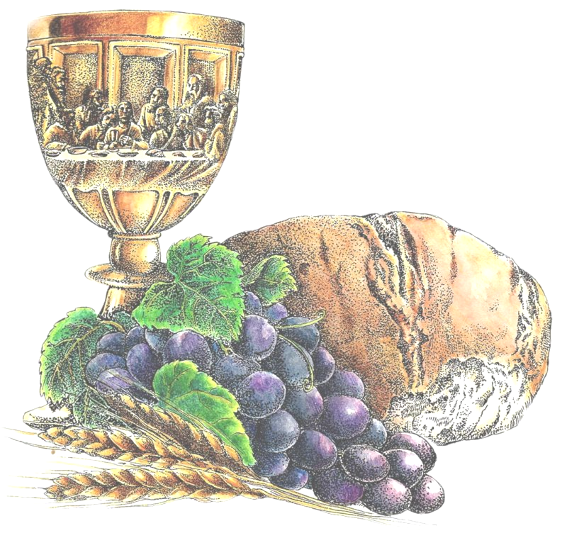

50° ORDENACIÓN SACERDOTAL

06/03/1966 P. Baumann Reinhold
06/03/1966 P. Weeger Franz
06/03/1966 P. Weiss Reinhold
26/03/1966 P. Cipollone Rodolfo
26/03/1966 P. Pierli Francesco
26/03/1966 P. Zárate Quiroz Baltazar
19/05/1966 P. Baritussio Arnaldo
19/05/1966 P. Lenzi Francesco
19/05/1966 P. Redaelli Enrico
28/05/1966 P. Gasparini Luigi;
28/05/1966 P. Jansen William Jacob
26/06/1966 P. Agostini Armando
26/06/1966 P. Dalla Vecchia Giuseppe
26/06/1966 P. Ferraboschi Davide
26/06/1966 P. Guiducci Giancarlo
26/06/1966 P. Petrogalli Eugenio
26/06/1966 P. Porto Mario
26/06/1966 P. Pozza Aldo
26/06/1966 P. Prandina Piergiorgio
26/06/1966 P. Tonolli Bruno
28/06/1966 P. Campanini Antonio
28/06/1966 P. Capaccioni Giovanni
28/06/1966 P. Casagrande Luigi
28/06/1966 P. Ceriani Giuseppe
28/06/1966 P. Coppe Daniele
28/06/1966 P. Martinelli Marco
28/06/1966 P. Martinho Lopes Moura
28/06/1966 P. Noventa Franco
28/06/1966 P. Savoia Elio
28/06/1966 P. Spadavecchia Cosmo Vittorio
29/06/1966 P. Hieber Hans
29/06/1966 P. Knapp Josef Valentin
29/06/1966 P. König Josef
29/06/1966 P. Michaeler Walter
29/06/1966 P. Weiss Alois
03/07/1966 P. Álvarez Gómez Antonio
03/07/1966 P. Cervantes Fajardo Aurelio
03/07/1966 Mons. Rodríguez Salazar Jaime
03/07/1966 P. Villalva Arroyo Héctor

25° ORDENACIÓN SACERDOTAL

13/04/1991 P. Ceja Ceja Filomeno
15/06/1991 P. Esti Giovanni Maria
15/06/1991 P. Sala Danna Mario
22/06/1991 P. Vailati Marco
06/07/1991 P. Piñón López Ismael
13/07/1991 P. Román Medina José Luis
20/07/1991 P. Martínez García Anastacio
27/07/1991 P. Navarrete Arceo Miguel
27/07/1991 P. Ramírez Ramírez Homero Gerardo
03/08/1991 P. López García Antonio
24/08/1991 P. De Robertis Corrado
12/10/1991 P. Rojas Zevallos Ibercio
19/10/1991 P. Annis Paul



50° VOTOS PERPETUOS

06/01/1966 P. Knapp Josef Valentin
06/01/1966 P. Michaeler Walter
19/03/1966 Hno. Sánchez Barajas Rodolfo
01/05/1966 Hno. Coronini Luigi
15/08/1966 P. Rossi Piergiorgio
05/09/1966 Hno. Salbego Luigino
09/09/1966 P. Agostinho Carvalho Alves
09/09/1966 P. Baltz David Paul
09/09/1966 P. Casagrande Luigi
09/09/1966 Hno. Dal Santo Narciso Tarcisio
09/09/1966 P. De Marchi Benito
09/09/1966 P. Fernando Correia Guimarães
09/09/1966 Mons. Franzelli Giuseppe
09/09/1966 P. González Fernández Fidel
09/09/1966 P. Gregório Rodrigues dos Santos
09/09/1966 P. Marini Luciano
09/09/1966 Hno. Matias Martins dos Santos
09/09/1966 P. Melzani Stefano
09/09/1966 P. Modonesi Alberto
09/09/1966 P. Negrini Raimondo
09/09/1966 Hno. Padovan Francesco
09/09/1966 P. Pellerino Giuseppe
09/09/1966 P. Pescantini Umberto
09/09/1966 P. Previdi Giorgio
09/09/1966 P. Raimondo Ottavio
09/09/1966 P. Sans Balcells Isidro
09/09/1966 P. Zanardi Silvestro
09/09/1966 P. Zanatta Emilio
01/11/1966 Hno. Dalla Vecchia Renato
01/11/1966 Hno. Soster Giovanni

25° VOTOS PERPETUOS

27/01/1991 P. Esti Giovanni Maria
27/01/1991 P. López García Antonio
27/01/1991 P. Martínez García Anastacio
15/03/1991 P. Rojas Zevallos Ibercio
19/03/1991 Hno. Montoya Mondragón Gustavo
21/04/1991 Hno. Artur Fernandes Pinto
01/05/1991 Hno. Kulitsi Tasile Jean-Marie
01/05/1991 Hno. Óscar José Araújo Gomes da Cunha
28/06/1991 P. Flores Contreras Oscar Eduardo
27/09/1991 P. Castillo Matarrita Víctor-Hugo
27/09/1991 Mons. Odelir José Magri
10/10/1991 P. García Oviedo José Manuel
10/10/1991 P. Jaramillo Arias Pablo Eduardo
10/10/1991 P. Llamazares González Miguel Ángel
10/10/1991 P. Melaku Tafesse Amente
10/10/1991 P. Vargas Egüez Ramón Alberto
26/10/1991 Hno. Albanese Gianni
23/11/1991 P. Ciuciulla Pietro
23/11/1991 P. Guerrero Zúñiga Gustavo
01/12/1991 P. Coaquira Hilaje Rodolfo
14/12/1991 P. Kyankaaga Ssendawula John Richard

75° VOTOS TEMPORARIOS

07/10/1941 P. Bonfitto Michele
07/10/1941 P. De Berti Aleardo jr.
07/10/1941 P. Lubich Mariano
07/10/1941 P. Zanoli Alessandro

50° VOTOS TEMPORARIOS

01/05/1966 Hno. Gil Dávila Luis
15/08/1966 P. António Alexandre da Rocha Ferreira
15/08/1966 P. Clemente Rey Vicente
15/08/1966 P. Delgado Domingo José
15/08/1966 P. Donohue Paul Michael
15/08/1966 P. González Núñez Juan Antonio
15/08/1966 P. Navarro Catalán Ramón
15/08/1966 P. Otero Magán Gabino
15/08/1966 P. Rubio Aguerri José
15/08/1966 P. Tenías Fenollé Juan José
15/08/1966 P. Torres Gómez Manuel Ramón
15/08/1966 P. Vale Insua José Luis
09/09/1966 P. Canovi Marco
09/09/1966 P. Capelli Luigi
09/09/1966 P. Crimi Claudio
09/09/1966 Hno. Croce Elio
09/09/1966 P. Crozzoletto Provvido
09/09/1966 P. Cusini Firmino
09/09/1966 P. Dorin Giorgio
09/09/1966 P. Farronato Elio
09/09/1966 P. Gasbarro Claudio
09/09/1966 P. Gilli Bruno
09/09/1966 P. Girardi Dario
09/09/1966 P. Masini Corrado
09/09/1966 P. Milan Pietro
09/09/1966 P. Modonesi Renato
09/09/1966 P. Moser Luigi jr.
09/09/1966 P. Parladé Escobar José Javier
09/09/1966 Mons. Perin Guerrino
09/09/1966 P. Rizza Francesco
09/09/1966 P. Robledo Silvestre Esteban
09/09/1966 Mons. Russo Michele
09/09/1966 P. Sesana Renato Kizito

25° VOTOS TEMPORARIOS

27/04/1991 P. Alvarado Ayala Javier
27/04/1991 P. Cerda Contreras Mario
27/04/1991 P. Mwambi Karloli
27/04/1991 P. Mwariri Joseph Maina
27/04/1991 P. Pesquera Roa Eduardo
27/04/1991 P. Rodríguez Pérez Pablo Simón
27/04/1991 P. Romero Morales José Angel Santos
27/04/1991 P. Villaseñor Gálvez José de Jesús
01/05/1991 P. Abraham Hailu
01/05/1991 P. Tesfaye Tadesse Gebresilasie
04/05/1991 P. Leandro Araya Leonardo
05/05/1991 P. Barrera Pacheco Luis Alberto
05/05/1991 P. Oñate Rebolledo René Alfonso
05/05/1991 P. Zúñiga Paredes Roy Carlos
18/05/1991 P. António Carlos Simões Ferreira
18/05/1991 P. Bedin Alessandro
18/05/1991 P. Cosentino Giovanni
18/05/1991 P. Dal Santo William
18/05/1991 Hno. Foglio Giuseppe
18/05/1991 P. Martín Vargas Francisco José
18/05/1991 Hno. Paternoster Egle Serafino
18/05/1991 Hno. Patt Fabio
18/05/1991 Hno. Paulo Manuel Félix Ferreira
18/05/1991 P. Pitton Gianluigi
18/05/1991 P. Robol Massimo
19/05/1991 P. Baeza Gama José Manuel
19/05/1991 P. Katsan Fodagni Kokouvi (Fidèle)
23/06/1991 P. Francisco de Assis Coqueiro
23/06/1991 P. Vanderlei Bervian

