Ministering to Refugees and Asylum-Seekers
London Province

“You should make hospitality your special care” (Romans 12:13)

For the last twelve years the London Province has maintained a pastoral presence among vulnerable refugees and asylum-seekers (of all faiths and of none) coming from Africa and the Far East to the United Kingdom, with Father Tesfamichael Debesay, Father John Clark, and more recently Father Louis Kouevi, assigned to this Ministry. Our Confrérès work in collaboration with the Jesuit Refugee Service (JRS), the London Churches Refugee Network (LCRN), the ‘Notre Dame de France’ Centre in Trafalgar Square, and other Refugee Organisations.

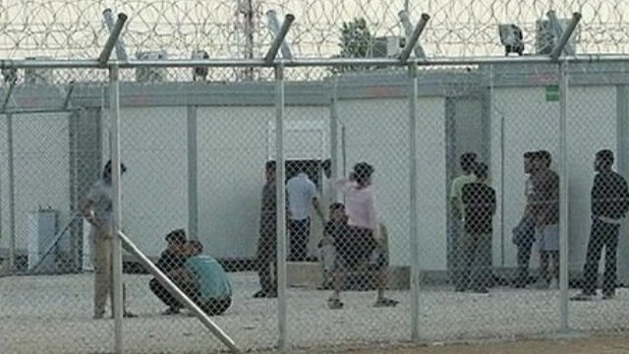
Our Confrérès are actively involved with:

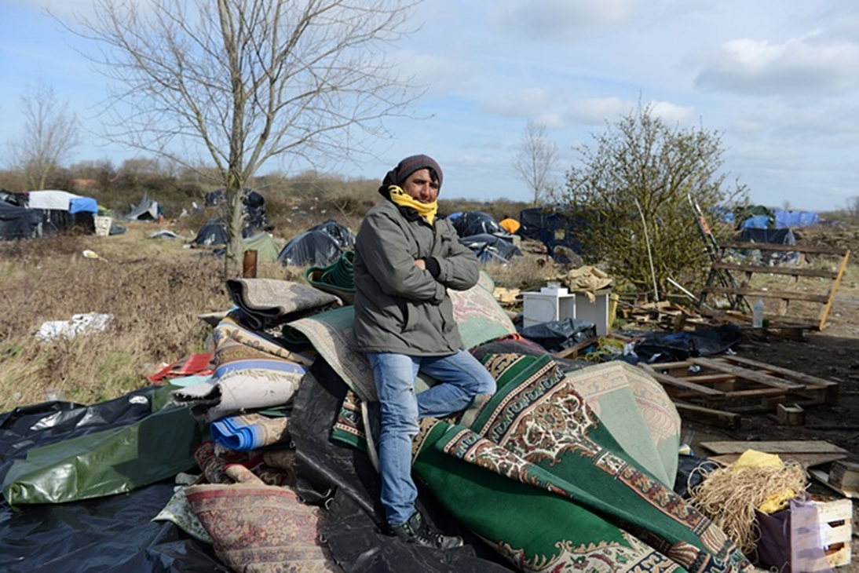
- Visiting the many hundreds of detainees who are being held indefinitely in the ‘Immigration Removal Centres’ in Colnbrook and in Harmondsworth, in the ‘Women’s Detention Centre’ in Yarl’s Wood, and beyond: chaplaincy work, befriending and offering counselling and support (telephone cards and postage to enable contact with members of their family and their legal representatives; toiletries; …);

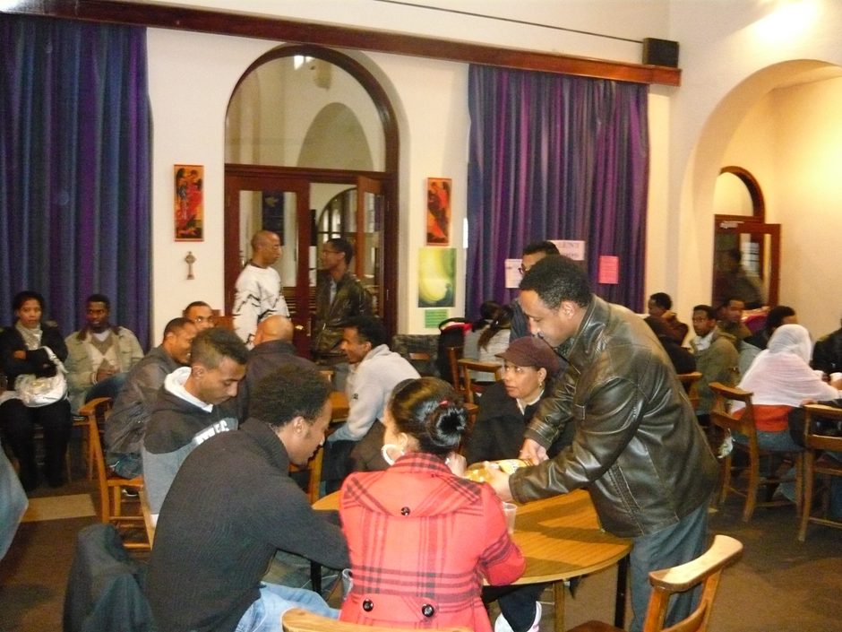

- Welcoming asylum-seekers: offering friendship from their first arrival until they are satisfactorily settled, and giving information about local services and making referrals to other Organisations and Churches for further support (interpreting, home visits, accompanying asylum-seekers and refugees to appointments and Court);
- Mentoring refugees: supporting and encouraging them to integrate with their local community, and creating opportunities for them to socialise and meet other people;

- Raising awareness regarding the plight of refugees and asylum-seekers in our midst in the Local Church and in society at large.

