SOUTH AFRICA

HELPING THE CHURCH TO BECOME MISSIONARY

Since 1989 the Province of SA is publishing a bimonthly magazine, Worldwide. We are celebrating the 25th anniversary of its birth (October/November 1989).

Later on, a liturgical and missionary calendar was also published by the Comboni Missionaries, which is now very much appreciated and spread in the whole country.

Through the years various efforts were made to promote the magazine and of the calendar. However, it is during the last 5 years that the province of RSA decided to invest more in the work of Mission Promotion, making available a confrere full time for Mission Promotion, creating a Missionary Centre in Pretoria, and improving the quality of the magazine and other publications.

At present, the province prints every two months:
- 4.500 copies of the magazine;
- 5.000 copies of the Comboni Friends Newsletter.

Every year 45 to 50.000 copies of the calendar are also printed.

Other publications are:

- Missionary Rosary Booklet in English (2nd edition), Zulu and Sotho (1st edition). We printed 3.000 copies of each language.
- Daniel Comboni booklet – 3000 copies
- Daniel Comboni comics: The defender of the Africans – 3000 copies
- On Comboni’s Plan – save Africa with Africa: 3000 copies
- History of the province – Fr. Konrad Nefzger – 500 copies – in fieri.

At the level of APDESAM, the province of RSA collaborated in the publication of these two booklets:
- Daniel Comboni, a journey to Holiness, of Fr. Vittorio Moretto
- This path could be yours (vocational) of Fr. Neno Contran.

The RSA province is committed to help the Catholic Church to become more missionary.
The above mentioned publications and the organization of the Comboni friends group in the different places where we work are powerful means to achieve this goal.

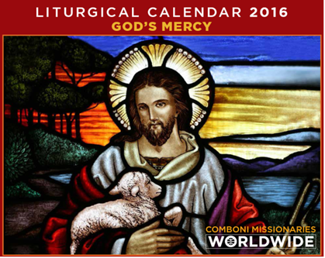
Pontifical Missionary Societies: Last Year 2014, the Episcopal conference asked a Comboni missionary to take over the direction of the PMS. Fr Gordon Rees was appointed as National Director for a period of 5 years.

Although we are finding many difficulties to carry out this endeavour we firmly believe that this is a meaningful work of the Province in the context of a Church too much inward looking.



