Familia Comboniana

MONTHLY NEWSLETTER OF THE COMBONI MISSIONARIES OF THE HEART OF JESUS

759 January 2018



The Holy Father suggests “four milestones towards welcoming asylum seekers, refuges and victims of trafficking:
Welcome,
Protect,
Promote,
Integrate”.

“To discover that they do not come empty-handed: they bring a load of courage, abilities, energy and aspirations and so enrich the lives of the nations that receive them”.

GENERAL ADMINISTRATION

CONSULTA DECEMBER 2017

- General Economate

  - Bro. Marco Binaghi has been appointed Bursar of the Curia Community as from 1 January 2018.
  - Bro. Marco Binaghi has also been appointed a member of the General Economate as from 1 January 2018.
  - The GC wishes to thank the NAP Province for their great generosity towards the General Administration and especially to the General funds for sick confreres and the Formation-Education Fund.
  - The GC also wishes to thank the circumscriptions of Asia, Central Africa, Colombia, DSP, Ecuador, EGSD, Ethiopia, Italy, Kenya, the London Province, Mexico, the NAP, Portugal, Spain, South Sudan and Chad who have sent in their contributions to the GA.
  - The GC has suggested that the General Economate should deeply reflect upon solidarity between the various circumscriptions and also with the local Churches. The GC hopes that this reflection may involve all the circumscriptions so that their superiors may bring its results to the Inter-capitular Assembly.

- Year for Revisiting and Revision of the Rule of Life

  - The GC reminds us that, with regard to implementing the 2015 Chapter Acts, it was decided to dedicate the year 2018 to revisiting the Rule of Life. With its letter, the GC encourages both circumscriptions and individual confreres to commit themselves seriously to this work.
  - The GC informs us that will be offered “reflection inserts” prepared by the General Administration and other confreres chosen from the continents and sub-continents. These inserts will be published in Familia Comboniana and will assist personal and communitarian reflection in all circumscriptions.

- General Administration Directory

Following the revision carried out by Fr. Lorenzo Frattini and having consulted a Canon Lawyer of the Holy See, the GC approved the corrections made to that part of the Directory of the GC which deals with “The Administrative Management of the particular situations of confreres”. An insert of this part of the Directory will be made and distributed to circumscription superiors so as to facilitate their service to confreres living in particular situations. The GC wishes to thank the confreres who collaborated to produce this part of the Directory. The first part of the GA Directory will be produced and approved in due course.

4. General Secretariats: statutes and councils

The GC has approved ad experimentum up to 2020 the statutes of the three General Secretariats (Formation, Mission, Economy) and has appointed the members of the three enlarged secretariats:

  - Formation: Fr. John Baptist Opargiw, Fr. Siro Stocchetti, Fr. Fermo Bernasconi, Bro. Guillermo Casas, Fr. Elias Sindjalim, Fr. Jude Burgers, Fr. Fidèle Katsan, Bro. Alberto Parise, Fr. Pablo Rodrigo Reveles Vázquez and Fr. Rogelio Bustos Juárez (liaison).

  - Mission: Fr. Mariano Tibaldo, Fr. Arlindo Pinto, Fr. Martin Devenish, Fr. Dario Bossi, Fr. Richard Kyankaaga, Fr. Victor Kouande, Bro. Alberto Lamana (liaison).

  - Economy: Fr. Claudio Lurati, Bro. João da Silva Ferreira, Bro. Guillermo Casas, Bro. Giuseppe Lagattolla, Bro. Marco Binaghi, Fr. Manuel Ferreira Horta, Fr. Fabio Carlo Baldan, Fr. Vítor Manuel Beco Anciães, Fr. Paolo Latorre, Fr. Sebastian Chmiel, Fr. Gonzalo Antonio Dasilva Fernández, Fr. Pietro Ciuciulla (liaison).

- Intercapitular Assembly
On 1 January 2018 the GC sent to all circumscription superiors the letter convoking the Intercapitular Assembly to be held from 9 to 30 September 2018.

- Continental Reference Brother
Europe, APDESAM and Francophone Africa have already elected their Continental Reference Brother who will take part in the Assembly of Provincials as requested by No. 71 of the Chapter Acts. We are still waiting for America/Asia to conclude the election process. When this is complete, the GC will communicate the results to all in one of the general notes.

- Celebrations for the 150th Anniversary of the Institute
The GC wishes to thank the circumscription superiors, the members of the ad hoc committee and all who worked to prepare and carry out the various activities for the celebration of the 150th Anniversary of the Foundation of our Institute. The various celebrations helped us to come to know better the gift of the missionary vocation of so many missionaries who continue the work initiated by our Father and Founder, St. Daniel Comboni.

The GC also thanks the various confreres responsible for the translation, publication and distribution of the book written by Fr. Manuel Augusto Lopes Ferreira. This provided us with a picture of our missionary Family. The GC wishes that this material be used to come to know the way God continues to manifest himself through our service to the Church and the world.

- Mixed Institute Commission
In April 2017 the Union of Superiors General (USG) sent a letter to the Pope requesting that the Brothers have access to all the structures of government of their Institutes. A USG commission has studied the question and proposes that the relative Dicastery be authorised to accord this privilege to the clerical religious institutes on request. By so doing, the canonical complications of this complex question would be avoided. The GC considers it opportune to await the reply of the Vatican to this request before creating the commission (CA 2015 No. 53).

- Consulta Calendar for 2018
02 - 24 March
02 - 03 (FC) 4 - 27 June
03 - 05 September
09 - 30 September Intercapitular Assembly
08 - 31 October
12 - 20 November

- Visits by members of the CG
r
Fr. Tesfaye Tadesse Gebresilasie
28 December – 21 January: visit to the province of Togo with Fr. Ciuciulla

Fr. Jeremias dos Santos Martins
21 December – 3 January: in Portugal
18 January – 28 February: visits to Uganda and Kenya

Fr. Pietro Ciuciulla
28 December – 21 January: visit to the prov. of Togo with Fr. Tesfaye
01 – 15 February: Assembly in Congo
19 – 26 February: meeting of circumscriptions in Nairobi

Fr. Rogelio Bustos Juárez
20 December – 11 January: in Mexico
12 – 30 January: visit to the province of Central America

Bro. Alberto Lamana Cónsola
16 – 21 December: in Spain
02 – 20 January: visit to South Sudan
20 January – 17 February: visit to Uganda with Fr. Jeremias

Rome, 15 December 2017

“Expound to me the way of your statutes, Lord, and I will always respect them. Explain to me how to respect your Law and how to observe it wholeheartedly” (Psalm 119, 33-34)

Dear Confreres, Greetings in Our Lord Jesus Christ.

As we begin the New Year of 2018, dedicated to revisiting and revising the RL, we turn to each one of you to encourage you to enter into this process with a spirit that is free and open to God’s surprises. We believe that this process, inspired by the Holy Spirit through the Chapter event (“revisiting and revising the Rule of Life”, CA 2015, 49) is a time of grace that is being offered to us. All of us are asked to put our whole heart and our missionary passion into it, with a deep sense of belonging to our Comboni Institute. Among the many initiatives for the process of revisiting the Rule of Life, we shall have animation and reflection at Institute level, with the preparation of material that we shall share with the entire Institute through Familia Comboniana. The first “insert” in Familia will be prepared by the General Council and the remaining five “inserts” will come from various confreres in the continents or sub-continents. With our eyes fixed on Jesus, accompanied by our Founder and Father, St. Daniel Comboni, and while incarnated in the missionary situations in which we live and work, we feel it is our duty to mention three crucial points for this process that we are undertaking together.
First and foremost, we wish to say that, present in the foundation and the beginnings of our consecrated missionary life is the person of Jesus whose Heart hears the cry of the people, the cry of the poor and of all who thirst for justice and peace, and wants us all to be his missionary disciples.
Secondly, we wish to keep before us the living figure of our Founder Daniel Comboni. The increased understanding of his person in recent years, his canonisation and the relevance of his charism for the world, are one more invitation to keep him as our reference point, to know him better and to share his charism and his holiness with the people among whom we live and work.
Lastly, a further important aspect of this process is to be attentive to the signs of the Spirit present in the world, within the Church and the Institute. The situation in which we live the mission is the “theological locus”, the revelation of God for us today. We commit ourselves to being careful “not to let ourselves be deceived”, but to be vigilant so that, when the Lord comes, he may find us at our place like servants awaiting his coming.
May the Lord Jesus and our Founder assist us to live with confidence and joy this process that we are starting as brothers from many different cultures and races but all carved from the same rock, Comboni and his charism.

The General Council

Perpetual Professions
Bro. Yata Blawo Lik. Christophe (T) Lomé-Cacaveli (TG) 03.12.2017
Sc. Esseh Kossi Michel (T) Donomanga(TCH) 17.12.2017
Fr. Italo Scoccia (M) Chitima (MO) 10.12.2017

Holy redeemer Guild
January 01 – 15 A 16 – 31 BR
February 01 – 15 C 16 – 28 EGSD

Prayer Intentions
January – That we may learn to care for what God has created by taking part in authentic natural and human ecology, overcoming the economic, social and environmental crisis that endangers the planet and all humanity today. Lord hear us.
February – That our new encounter with the Rule of Life may reawaken in all Combonis that zeal for evangelisation which inspired our Founder. Lord hear us.

Publications
Juan Benjumea Ramos, De los toros a la misión, Editorial Mundo Negro 2017. A biography recounting the story of a life that may be divided, as the author himself says in the introduction, into two distinct periods: the first tells of Juan the bullfighter, and the second tells of Juan the Comboni missionary, first as a Brother and then, at the age of 51 years, as a priest.

ITALIA

Fr. Albanese receives the Franco Cuomo International Award
Fr. Giulio Albanese, director of Popoli e Missione and other Catholic publications, on 1 December in Rome, received the prestigious ‘Franco Cuomo International Award’, named after the writer, journalist and dramatist Franco Cuomo who died in 2007.
This award comprises four sections (Literature, Journalism and Non-fiction, Theatre and Art) and has as its object to award those forms of cultural, artistic and human expression that see the future through dialogue and encounter, appreciating past experiences and the differences between people and world visions. As we are aware, Fr. Giulio Albanese, as he has also done in his more recent writings, writes of the Africa of the past to speak of Africa of the present, seeking to find ways to build up the future.

PM Exhibition on its 90th Anniversary
Following the success of the exhibition held from 10 October to 4 November 2017 at the Civic Library of Verona entitled “’Africa is 90!” that showed the African continent through the illustrations and cartoons from the ninety years of Piccolo Missionario publications, the same exhibition is being displayed at the African Museum from 12 December to 21 January. It is hoped that this will be an occasion to make the magazine known and to receive subscriptions to it.

Magic and medicine
From 2 February to 11 March, the African Museum will host a photographic exhibition on the theme of magic and medicine, sickness, grace and healing in Africa.
The more than fifty artistic photos are by Massimiliano Troiani. A catalogue/book edited by Effata will be available at the special price of €15.00.

Film on “Travellers and Migrants”
This year, the section of the “Travellers&Migrants” films from the African Film Festival will be shown in our Africa Hall each second Friday from January to May 2018.

MOZAMBICO

Fifty years in the diocese of Beira
On 3 December, the feast of St. Francis Xavier, patron of the circumscription, at the parish of the Immaculate Heart of Mary, in Alto da Manga, Beira, the Combonis celebrated fifty years of presence in the Archdiocese.
The day began with a Eucharistic celebration presided over by Archbishop Mons. Cláudio della Zuana, attended by a number of confreres, missionaries, religious, diocesan priests and the faithful. In his homily, Mons. Cláudio thanked the Combonis for their presence, especially in the prioritised fields of formation and education. At the end of the Mass, the provincial superior also thanked everyone for attending, renewing our missionary commitment and our obedience and fidelity to this local Church.
An especially beautiful part of the festivities consisted of a play prepared by the mothers who received the first Comboni Missionaries into the parish whose manner of speaking and evangelising they still remembered!

Perpetual vows
On 10 December, at the parish of St. John XXII, Chitima, Fr. Italo Scoccia made his final profession during a Mass presided over by the provincial superior Fr. Constantino Bogaio, in the presence of many confreres, religious, priests from the pastoral region of Songo and the faithful from several parishes, especially that of Santa Maria de Mucumbura.
In conclusion, the faithful thanked Fr. Italo for choosing to make his definitive consecration in the parish of Chitima which, for the first time in these fifty years, witnessed such a ceremony.

PCA

Seminar on the Rule of Life
From 4-8 December 2017, at the provincial house of the De La Salle Brothers, Guatemala City, a seminar was held on our Rule of Life, organised by the Central Commission for revisiting and revising the Rule of Life, for the American Circumscriptions.
Representatives of all the provinces and delegations of the continent took part: Bro. Simone Bauce, representing Ecuador, Fr. Luis Alfredo Pulido (Colombia), Fr. Pasquale Miniero (Guatemala, facilitator), Fr. Víctor Hugo Castillo (Provincial of the PCA, Central Commission), Fr. Damián Bruyel (PCA), Fr. Gabriel Martínez (Mexico, Central Commission), Fr. Alfredo del Toro (PCA), Fr. Carlos Humberto Rodríguez (PCA), Fr. Francisco José Martin (Provincial of Peru), Fr. Massimo Ramundo (Brasil), Fr. Romeo Barrios (Ecuador), Bro. Humberto da Silva Rua (PCA), Fr. Jorge Elias Ochoa (NAP), Fr. Tomás Herreros (Perù).

IN PACE CHRISTI

Fr. Weiss Reinhold (15.01.1936 – 29.11.2017)
“I did the novitiate together with Fr. Reinhold Weiss” – writes Fr. Reinhold Baumann – “and attended the theological faculty of Bamberg. Last year we celebrated together the fiftieth anniversary of our priestly ordination. For the past twenty years we were members of the community of Ellwangen. However, I ask myself: Did I really know him? Perhaps he, too, would have had his doubts. Despite this, I shall endeavour to present him as I knew him”. The following are some passages by Fr. Reinhold, for Familia Comboniana.
He was born on 15 January 1936 at Weingarten/Baden-Württemberg, not far from Lake Constance. After the second World War, his two elder brothers started a plastics factory at Wehingen. Fr. Reinhold, like his brothers, was always very interested in technical and electronic things as well as the nascent digitalisation.
Fr. Reinhold had for some time felt attracted to the missionary life. He therefore went to Bamberg where it was possible to attend night school and sit for the final secondary school exams. His mother had known a Comboni Missionary and so he found lodgings at the house of the Combonis and attended the school run by the Carmelites. In 1959 he entered the novitiate of Mellatz.
It was there that we met for the first time. We were twenty novices in all. Almost all of us were from the seminary. Fr. Reinhold was four years older than the other novices. He had had more experience of life and had a driving licence.
It was the time of the Council and the revolution of 68. We young scholastics felt we were the leaders of a new era. Reinhold seemed to be a mature person and sure of himself. The superiors trusted him and gave him the task, even though he was only a scholastic, of preparing two editions of the calendar for the “Holy Redeemer Guild” (1964 and 1965), the second with my collaboration. In the spiritual field, too, there was a new atmosphere. The two of us would meet every week with Fr. Alois Weiss to read and share together the Word of God and discuss theological themes.
I believe the superiors expected great things from Fr. Reinhold. After his ordination in 1966 they sent him to South Africa, equipped with a camera to take pictures and collect material for the magazine. That was the first time the superiors permitted anyone to do such a thing. He returned with over 3,000 slides that are still to be found in the provincial archives, properly catalogued and computerised. I think Reinhold was the first in the province to have a computer.
On his return from South Africa he was appointed formator at the seminary of Bad Mergentheim and, in 1970, of the seminary of Milland. From 1975 to 1978 he was military chaplain to the great barracks of Ellwangen.
In 1978 he was assigned to the community of Limone. Even before the reunion there was an exchange of personnel between the two Institutes. Fr. Weiss willingly accepted the appointment and learned Italian quite well. Limone is a holiday resort frequented by many Germans and many of them stay there almost the whole year round or during the summer and a number of them would visit the house of the Founder. Gradually they discovered in Fr. Weiss a good intermediary, always available to give a word of advice or offer spiritual direction.
In 1987 he was assigned to the DSP and appointed superior of the small community of Pocking until it was closed in 1989. From 1989 to 1993 he worked at the community of Ellwangen as superior and, from 1993 to 1996 as provincial secretary at Bamberg. From 1997 up to his death, he was a member of the community of Ellwangen.
At Ellwangen he acted as spiritual director to the elderly confreres and willingly assisted the nearby parishes. At the same time, he did research work on Comboni. He had discovered Comboni during his years at Limone. It was the time of the reunion of the two Institutes (1979), of the centenary of Comboni’s death and, later, that of his beatification and canonisation. Fr. Reinhold translated a number of letters of Comboni into German.
Due to serious health problems, he never went back to the mission.
In conclusion, I would like to mention the Bible group, of which he was the spiritual director, that gathered regularly at our house.
Father Reinhold now rests in the cemetery of Ellwangen, next to 68 other confreres; 40 Priests and 28 Brothers. (Fr. Reinhold Baumann)

Fr. Modesto De Bertolis (29.03.1929 – 16.06.2017)
Fr. Luigi Varesco (18.10.1926 – 06.10.2017)
Bro. Peter Schwingshackl (08.02.1939 – 21.11.2017)
Fr. Mario Locatelli (05.11.1932 – 19.12-2017)
Their obituaries will be published in the next issue of Familia Comboniana.

Let us pray for our beloved dead
THE FATHER: Manuel, of Bro. António Manuel Nunes Ferreira (SS).
THE BROTHER: Sandro Scattolin, of Fr. Giuseppe Scattolin (EGSD).
THE SISTERS: Rita, of Fr. Giovanni Baccanelli (ET); Anna Maria Grifoni, of Fr. Valeriano Grifoni (†).
THE COMBONI MISSIONARY SISTERS: Sr. M. Letizia Ferraresso; Sr. Nadia Germaine Minkarios Greiss.

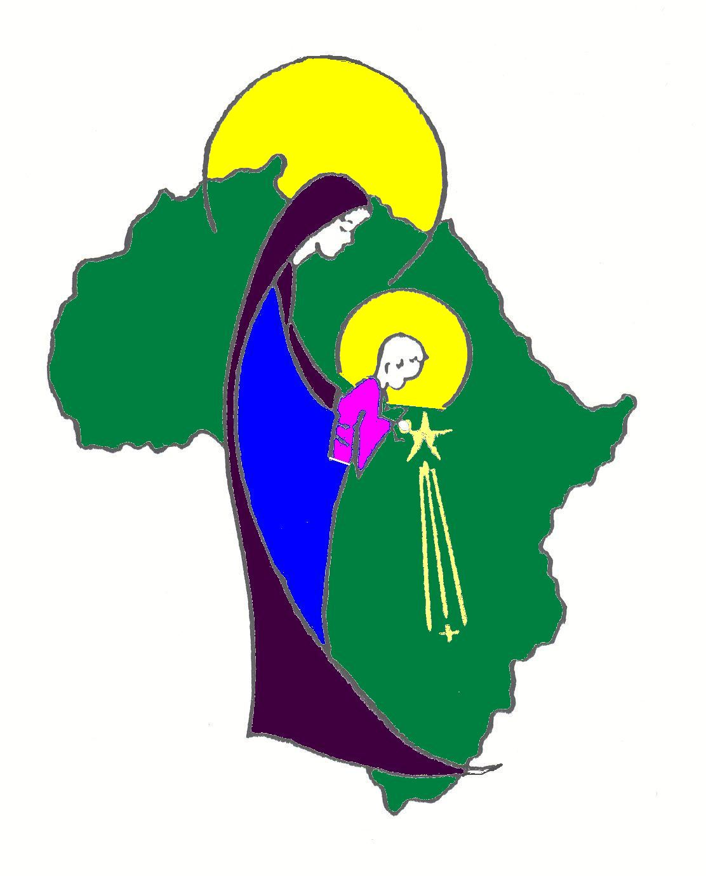

MISSIONARI COMBONIANI VIA LUIGI LILIO 80 - ROMA

