


Comboni Missionaries
South Sudan Province
JPIC OFFICE

PROVINCIAL JPIC-R COMMISSION/ANTENNA
A STRATEGIC PLAN FOR ACTION

- Promoting Justice, Peace and Reconciliation with both People and Creation

The promotion of Peace, Reconciliation, Social and Environmental Justice is not only an essential dimension of mission, but has become a particular urgency in the apostolic work. These values are indeed constitutive elements of evangelization and come from the words and deeds of Jesus of Nazareth who said: “The Spirit of the Lord is upon me, because he has anointed me to bring good news to the poor. He has sent me to proclaim liberty to captives and recovery of sight to the blind, to let the oppressed go free and to proclaim a year acceptable to the Lord” (Luke 4:18-19).

In his own time and ways, Daniel Comboni put that into his mission plan as he was sensitive to the human, social, religious and cosmic cry of Central Africa. His methodology inspired works for justice and peace, notably to empower local people as the main agents of their own liberation and transformation, to show and practice solidarity with them, to network around the world, to be part of a team, and to aim for integral human promotion.

In compliance with the Comboni charisma and tradition, the General Chapter of 1985 confirmed JPIC as an integral part of the mission of the Church and a priority of our Institute. And very recently, the Church in Africa, through the Africae Munus, has taken on the commitment of reconciliation, justice and peace so as to help build a reconciled Africa by pursuing the paths of truth and justice, love and peace.

- The Justice, Peace and Reconciliation (JPIC-R) Commission/Antenna

The Province of the Comboni Missionaries in South Sudan has formed a Provincial JPIC Commission, which can also be named ‘antenna’ for, as its very name suggests, it receives and transmits information and ideas on a regular basis among people who have common interests, just like a radio antenna concentrates radio waves and sends them over long distance. Similarly, the JPIC Provincial Commission/Antenna is set up for networking, which involves a process of circulation, articulation, participation and cooperation among individuals and groups so as to raise awareness on JPIC-R issues and to action on them. Eventually a commission/antenna member will have a JPIC-R full time commitment within the province and also to support JPIC-R at the level of Episcopal Conference.

- The members of the JPIC-R Commission/Antenna

The Comboni Missionaries in South Sudan have strategically chosen a missionary belonging to each of the Comboni missionary communities spread across South Sudan to join the JPIC-R Provincial Commission/Antenna. From their respective communities they are encouraged and expected to act networked for JPIC-R, both locally and (inter)nationally, having a JPIC animator to coordinate the work of the commission.

The members and their communities are as follows:

Fr. Juan Martin Alferez - Mapuordit community (alferezjm@hotmail.com)
Fr. Martin Isaac – Wau community (martinrf2_@hotmail.com)
Fr. Antoine Kondo – Yirol community (komivikza@yahoo.fr)
Fr. Phillip Andruga – Lomin community (phillipandruga@yahoo.com)
Fr. Jervas Mawut Mayik – Raga community (jmawtm@hotmail.com)
Fr. Daniele Moschetti – Juba community (JPIC APDESAM) (ssmccj@gmail.com)
Fr. Joe Vieira – Juba community (josedasilvavieira@gmail.com)
Fr. Luis Okot – Juba community (oh25_97@yahoo.com)
Br. Damiano Mascalzoni – Talí community (frateldamiano@fastmail.fm)
Sch. Ketema Dogne – Old Fangak community (ketema555@yahoo.com)
Fr. Raimundo Rocha – Leer community (JPIC Coordinator) (ranorocha@hotmail.com)

- The Spirituality of the JPIC-R Commission/Antenna

The JPIC-R Commission/Antenna goes to the roots of the importance of the social dimension of our faith. The words of Jesus at the Synagogue of Capernaum are the basis for the JPIC-R program of the Provincial Commission/Antenna. With the Gospel in our hearts and on our lips we carry out a prophetic mission wherever we are and in whatever we do.

Pope Paul VI said that the mission of Justice and Peace is that of keeping the eyes of the Church open, its heart sensitive and its hand prepared for the work of charity which it is called upon to realize in the world. This phrase helps us understand the spirituality of JPIC. Not only that. We are called to act justly, to live at peace and to promote it and to be reconciled with God, our brothers and sisters and the rest of creation before we do or teach JPIC-R to others.

- Challenges and Priorities for the JPIC-R Commission/Antenna

According to the answers collected from a questionnaire sent to the members of the JPIC-R Commission/Antenna, listed below are the main JPIC-R challenges that are found in our communities and missions:

- Land grabbing;
- Oil production-related socio-environmental issues;
- Reconciliation & Peace building;
- Human Rights;
- Constitution of South Sudan;
- Gender issues;
- Returnees;
- Good governance (fighting corruption);
- Reinforcement of Law.

- Methodology – How is the JPIC-R Commission/Antenna to work?

The JPIC-R Commission/Antenna will be engaged with the dissemination of information, sharing, formation and action in and around their missionary communities. Members will form an electronic network (e-mail), offer seminars and workshops on JPIC-R or invite guests to facilitate them, promote or take part in forums and support JPIC-R campaigns in partnership with the local churches and the civil society whenever possible.

An antenna receives and transmits information and ideas among people who have common interests.

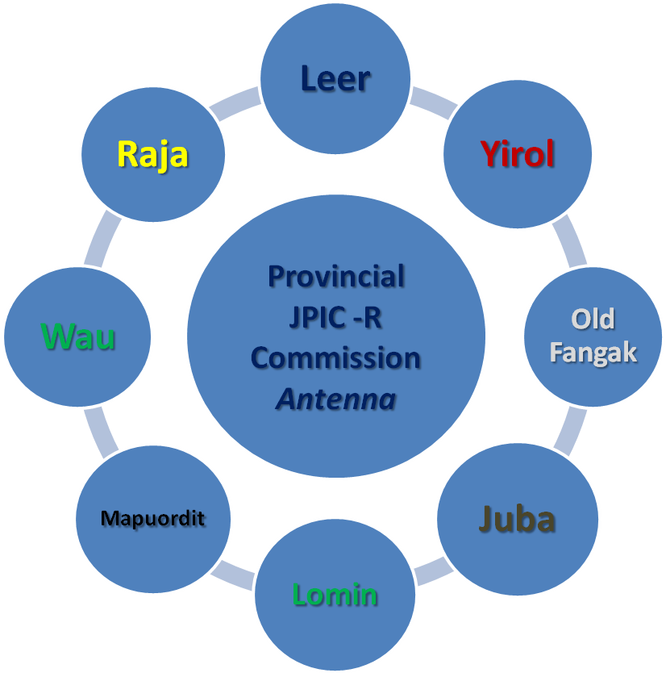

- Activities of the JPIC-R Commission/Antenna

- Local-short run permanent actions

Locally, the JPIC-R Commission/Antenna is expected to:

- Keep a daily spirituality of JPIC-R and seek formation in this area;
- Focus on the spirit and purpose of the provincial JPIC-R Commission/Antenna;
- Seek interaction with the Secretariat of Evangelization;
- Facilitate or invite facilitators to run seminars and workshops on the Social Teaching of the Church;
- Raise awareness on JPIC-R issues through preaching, teaching and writing articles;
- Promote a culture of respect and care for the environment;
- Initiate a campaign of a systematic planting of tree, especially where there is deforestation;
- Get involved in local process of reconciliation and peace building;
- Favour the promotion of Human Rights;
- Act justly with all, especially our workers;
- Instil in their communities a greater sensitivity about recycling, compost and organic agriculture, and renewable energies;
- Take part in the Constitutional Review Process and encourage others to do the same;
- Write and share articles on JPIC-R to update the Provincial Website and Newsletter;
- Be attentive and get involved in the preparation of the next Comboni Social Forum for the World Social Forum to be held in Tunis, Tunisia in March 2013;
- Collaborate with the preparation and participate in the JPIC seminar (Easter 2013);
- Meet at least once a year in Juba before or after the provincial assembly;
- Share with their communities and other agents the monthly Comboni JPIC Network Bulletin from the North American Province.

The Africa Europe Faith and Justice Network Bulletin (from Brussels, Belgium) and the JPIC Newsbrief Bulletin (from the Justice and Peace Commission, Rome) are to be shared occasionally by the JIPC-R coordinator or the provincial himself, either in soft or hard copy, so as to avoid excess of information.

- Nation, continental and worldwide long run actions

Globally, the JPIC-R Commission/Antenna is expected to:

- Collect data and make analyses on land grabbing in their communities areas;
- Join other partners (MCCJ/CMS, local churches, civil societies) in JPIC campaigns;
- Include in the parish/school programs awareness on JPIC issues;
- Set up JPIC parish groups and reflect with them on the local JPIC-R challenges aiming at taking action;
- Work for lobbying and advocacy with other partners;
- Support and get involved with a continental campaign on land grabbing;
- Pursue further studies and on-going formation on JPIC and Human Rights areas;

Members of the JPIC-R Commission/Antenna based in Juba are to act as the main ‘antenna’ since Juba is the main centre of political decisions. Contact is also expected from the Provincial JPIC coordinator (Fr. Raimundo Rocha) and from the APDESAM JPIC Coordinator (Fr. Daniele Moschetti).

- Partners of the JPIC-R Commission/Antenna

As far as our actions, aims, and methodology are concerned, the JPIC-R Commission/Antenna is to act networked not only with the Comboni communities and the members of the commission/antenna themselves, but also with Fr. Arlindo Pinto (JPIC coordinator, Rome), Fr. Daniele Moschetti (APDESAM JPIC representative at continental level), local churches, other religious congregation and civil society, both nationwide and abroad.

- Financial Support to Run the Activities of the JPIC-R Commission/Antenna

An annual budget is to be made for ad hoc activities of the JPIC-R Commission/Antenna through the JPIC Provincial Office under the Secretariat of Evangelization.

- Calendar for JPIC-R

01/01 – World Day of Prayer for Peace
30/01 – Day of Peace and Nonviolence - Mohandas K. Gandhi (“Mahatma”), India, 1948.
01/03 – Anniversary of the Ottawa Treaty Against Landmines
08/03 – Women International Day
21/03 – International Day for the Eradication of Racism
04/04 – Birthday of Martin Luther King, Jr. (1929), a civil rights pastor activist.
01/05 – International Labour’s Day
15/05 – International Day of the Conscientious Objectors
04/06 – International Day of the Children Victims of Aggression
05/06 – International Day of Ecology and Environment
09/07 – Independence Day of South Sudan
06/08 – Memorial of Hiroshima Atomic Bomb
09/08 – International Day of the Indigenous Peoples
08/09 – World Day of Literacy
21/09 – International Day of Peace
16/10 – World Day of Food
17/10 – International Day for the Eradication of Poverty
20/11 – World Children Day
29/11 – International Day of Solidarity with the Palestinian People
01/12 – Day of Solidarity with the People Arrested for the Cause of Peace
01/12 – World Day of Solidarity with the Victims of AIDS
03/12 – World Day for the Abolition of Slavery
10/12 – World Day of the Human Rights
"We cannot do everything and there is a sense of liberation in realizing that. This enables us to do something, and to do it very well. It may be incomplete, but it is a beginning, a step
along the way, an opportunity for God's grace to enter and do the rest”.

Archbishop Oscar Arnulfo Romero y Galdámez,
Martyred in San Salvador, El Salvador, on 24th March 1980

Juba, July 2012.

