COMBONI JPIC NETWORK
The News Service of the Comboni Missionaries
North American Province


JPICN

December 2012 – Vol. 2. No. 12.

Selected Global News
Photos from alfredstree.com and Marie Cacace/Oxfam.

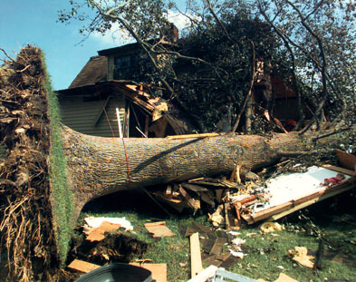
On the Edge of the Climate Cliff: Can the World Summit lead to more than “Stalemate and Failure?” This year’s weather ranged from Hurricane Sandy and a U.S. drought that pushed up food prices, to an Indian monsoon and floods in Europe. Melting across most of the Greenland ice sheet and the shrinking of the Arctic Sea ice are of utmost concern. Nearly 17,000 participants from 194 nations are now making an urgent plea for real progress on climate change at the U.N. Framework Convention on Climate Change in Doha, Qatar, ending December 7. Learn more and more, and click for webcasts. See The Ultimate Climate Change FAQ, here.

Changes to “Keep Fighting For” in Obama’s Second Term. President Obama’s re-election means holding him accountable for a list of significant changes. Many of these changes fall within The Center for Constitutional Rights’ focus issues: (1) illegal detentions and Guantanamo; (2) surveillance and attacks on dissent; (3) criminal justice and mass incarceration; (4) corporate human rights abuse; (5) government abuse of power; (6) racial, gender and economic justice; and (7) international law and accountability. Read more.

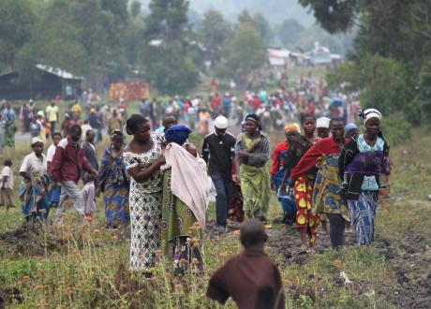
Eastern Congo: Armed Groups Unleash Terror as Displaced Numbers Escalate. With six million dead, the ongoing war in DR-Congo is the deadliest since World War II. Currently, about two million are displaced, the highest since 2009. 100s continue to arrive each day at the camps, including Kibati in Nyiragongo territory near Goma, which was captured by the M23 rebels. Recently, Bishop Bernard Kasanda of Mbuji-Mayi (DRC) condemned the U.N. and world leaders, for failing to act to stop the advance of M23, believed to be backed by Rwanda. On November 29, the U.N. Security Council extended the arms embargo and other sanctions for two more years, and hinted at additional sanctions targeting the M23. Click here. Read two reports: From CNDP to M23: The Evolution of an Armed Movement in The Eastern Congo, here, and The Background to Conflict in North Kivu Province, here. Also, Commodities of War, here. Call the U.S. Mission to the U.N. (212-415-4404) to demand more decisive action against Rwanda.
U.N. Conference on Arms Trade Treaty to take place in March. Diplomats have agreed to hold a final negotiating conference on arms control, from March 18-28, 2013 in New York. Following intense lobbying by civil society, the resolution contains a proviso that “if all states are not able to agree to a deal in March, the U.N. will keep the treaty on its current agenda.” This would allow the text to be sent for a final vote at the General Assembly later in 2013. Read more. Sign up for the Control Arms bulletin (multi-language), here.
Philippines: Framework Agreement on Bangsamoro. In mid-October, the Philippine government and the Moro Islamic Liberation Front (MILF) signed an historic agreement to hopefully end decades of armed conflict in the southern Philippines. The Framework Agreement on Bangsamoro, presently just an outline, is based on years of negotiations and on the recognition of a common struggle for peace and justice for the Muslim people of Mindanao (and other areas) and all Filipinos. There are14 more stages leading to the full creation of the Bangsamoro, or “political entity,” that creates basic law including a legislative assembly, if possible by 2016. Find out more, here. Read more.
Take Actions

♦ With budget negotiations in play to avert “the fiscal cliff,” Bread for the World’s 2012 Offering Letters is vital towards expanding the Circle of Protection around programs for the hungry and poor. Send a letter to a decision-maker, here. Send President Obama an appeal to end hunger, here. For Pan Para el Mundo, click here.
♦ Your voice is needed on a “new generation of development goals” that will follow the Millennium Development Goal framework, post-2015. An E-discussion, in two phases, runs through December 16. Get involved here.
♦ Support the Campaign to Cut Poverty in Half by 2020, here. Read “Half in Ten’s” annual report, The Right Choices to Cut Poverty and Restore Shared Prosperity, with new findings, here.
U.N. Observance Days for December are listed here.
U.N. News & Other Events

♦ December 1, 2012: World AIDS Day: Getting to Zero raises awareness of the ongoing AIDS pandemic. Click here. In Spanish; In French. Read more. For the President’s Emergency Plan for AIDS Relief (PEPFAR): Blueprint: Creating an AIDS-free Generation, click here. Get facts and take action, here.
♦ December 10, 2012: Human Rights Day recognizes the work of human rights defenders worldwide, and commemorates that day in 1948 when the U.N. General Assembly adopted the Universal Declaration of Human Rights. Click here. In Spanish; In French. For Amnesty International’s annual report on human rights, click here.
♦ December 18, 2012: International Migrants Day recognizes migrants and their fundamental rights to freedom, respect and protection. Read more; In Spanish; In French. For Pope Benedict XVI’s message, click here. Get involved at Global Migrants Action (multi-language), here.
♦ December 20, 2012: International Human Solidarity Day reminds us that “solidarity” is a fundamental, universal value that should underlie relations between all peoples. Read more; In Spanish; In French.
Resources

♦ Bread for the World’s 2013 Hunger Report: Within Reach-Global Development Goals, hot-off-the-press, explores the connection between hunger and the Millennium Development Goals (MDGs) and proposes that, after 2015, the next global development goals build a consensus on ending hunger and poverty. $20. Order here.
♦ The Catholic Peacebuilding Network (CPN), based at Notre Dame University, (Notre Dame, IN), is open to all faiths sharing common ground with the desire to increase their understanding of the unique role of the Catholic Church as a force for justice and peace. Get documents in English, Spanish and French, here.
♦ Mathematicians of the African Diaspora: In math, more than any other field, there are misperceptions about Africans’ lack of success in higher learning. However, ancient and present achievements debunk the myths. Learn about some of the incredible, little known, contributions of the peoples of Africa and the African Diaspora, here.
♦ The Rift Valley Institute (RVI) is a non-profit research, education and advocacy organization operating in Sudan, South Sudan, the Horn of Africa, East Africa, the Great Lakes and the DR-Congo. It works with communities, institutions and individuals to bring local knowledge to bear on political and economic development. Click here.
♦ Videos: (1) Acuerdos Comerciales UE, America Central, Colombia y Peru: Agua para la Vida o para el Comercio?: Watch here. (2) Farmageddon: The Unseen War on American Family Farms underscores the problem of rapidly disappearing family farms, many forced out of business by industrial food giants, policymakers and regulators intent on boosting agribusiness profits by eliminating competition. Watch here. Get backgrounding.
(3) The Line, from Bread for the World, shares stories of people in the U.S. and how charity impacts their lives, whether they’re “below the poverty line,” “standing in line,” or even on “the firing line,” a matter of life or death. Get link here. (4) Trade Justice: Alternative Visions from the Global South: Watch here.
JPIC Combonline

♦ Congratulations to the Comboni Missionaries - Asia Province on its 25th Anniversary, and, likewise, to World Mission magazine on 25 years. The latter recently received two Catholic Mass Media Awards for “best family magazine” and “best investigative report.” Read World Mission. The theme for this special year is MCCJ@25: Journeying Together on Asian Roads. The Year will open, as well as close, with the Friends of the Mission Fiesta.
♦ Fr. Miguel Angel Llamazares (Asia Delegation) participated in the recent VIVAT International Workshop in Manila.
♦ The Comboni Missionaries of South Sudan helped forge an initiative on abolishing the death penalty, along with other international human rights groups. This month, South Sudan has its first opportunity to vote on a U.N. General Assembly resolution to establish a moratorium on executions. Read the letter to the Foreign Affairs Minister, here.

1318 Nagel Road ♦ Cincinnati, OH 45255-3120 ♦ (513) 474-4997 ♦ FAX: (513) 474-0382
♦ To receive this newsletter, email combonipn@combonimissionaries.org; for all back issues,
click here. ♦ Web site: www.combonimissionaries.org; related articles at www.jpic-jp.org/en.php.

♦ Web site: www.combonimissionaries.org; related articles at www.jpic-jp.org/en.php.

Comboni Press Network (CPN) newsletter provides access to information on global issues from Church and Mission-related sources. Our focus is on Justice and Peace issues, and on how the U.S. policies affect the Third World countries. Please share your suggestions and ideas with us—we’re only an e-mail or fax away!

