COMBONI JPIC NETWORK
The News Service of the Comboni Missionaries
North American Province


JPICN

January 2013 – Vol. 3. No. 1.

Photos: Angel memorial: (Spencer Platt/Getty Images); Drone pilots (Gilles Mingasson/DER SPIEGEL)
Selected Global News

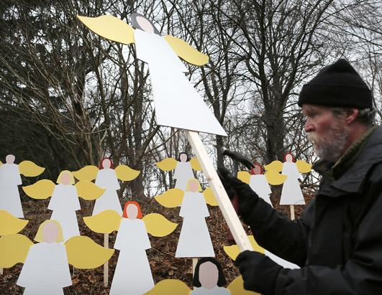
The U.S. at the Tipping Point: Gun Violence and Mental
Illness: The Sandy Hook Elementary School massacre (12/14/12),
perpetrated by a mentally ill gunman in Newtown, Connecticut, left 28 dead, including 20 innocent children and 6 teachers. In the aftermath, the Obama Administration has assigned a task force led by the Vice-President to review and recommend reforms within one month. It will specifically focus on banning military-style assault weapons and high-capacity magazines, in conjunction with reforming mental health policy. Can the nation’s anguish catalyze a movement towards a “nonviolent culture?” In this case, violent video games may have also played a role. Click here. Read more. “Demand a plan” to reform gun laws, here. Get involved in a campaign, here; One Million Moms for Gun Control on FB; and Brady Campaign on FB.
Additional Resources:
- For the U.S. Bishops Call for Action in Wake of Newtown Tragedy, click here.
- Read The Real Social Justice Issue: Taking Care of the Violent Mentally Ill (The Catholic World Report, 12/17/12), here. Read about the case for HIPAA reform, here, and “America’s secret health crisis,” here.

Gun violence is an epidemic in the U.S. and around the world. Consider the fact that weapon trafficking, just between the U.S. to Mexico, has resulted in at least 100,000 violent deaths in the last six years. It’s estimated that 70% of seized guns in Mexico can be traced back to the United States. The Washington Office on Latin America outlines different actions that President Obama can take—without the approval of Congress—to reduce gun violence. Stay abreast of the small arms & light weapons (SALW) global movement and the ATT. Read A Surfeit of Weapons, a Flood of Blood and Misery by John Converset, mccj, here. (p. 8). Visit International Action Network on Small Arms.

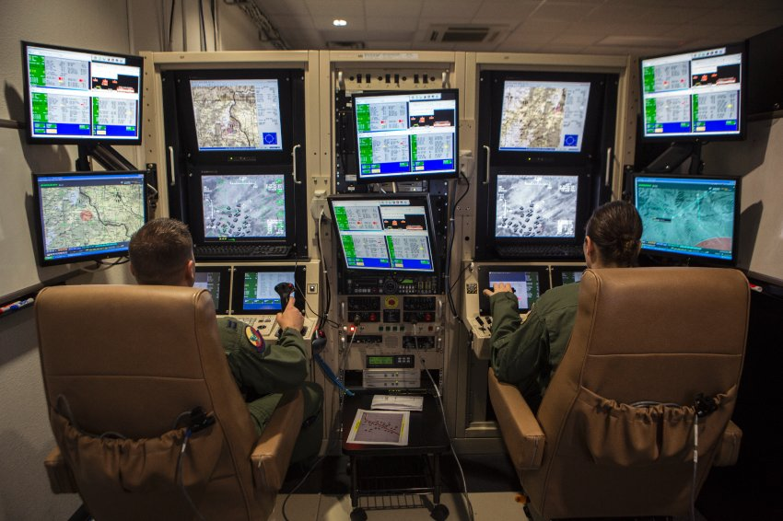
The Human Face behind Drone Strikes: “Did I Kill a Child?” The human costs of the drone war that the Obama administration has escalated are rarely talked about. Hundreds of civilians have been killed in Pakistan, Yemen and Afghanistan by U.S. drone strikes. Learn about the brutality inflicted by those waging war 1000s of miles away by remote control, here. Nicola Abé of DER SPIEGEL studied the negative effects on the drone pilots, read more. Read The Increasing U.S. Shadow Wars in Africa, here. For Pax Christi International’s statement on drones, click here, and for the article, Five Reasons Drone Assassinations are Illegal, click here.

2013 World Social Forum-Tunisia needs a real strategy on Land Grabbing. After the 2011 World Social Forum (WSF) in Dakar, Senegal, all the letters, protests and denunciations did little to diminish “land grabbing” around the world. At the upcoming 2013 WSF in Tunis in March, participants should prepare for success this time, rather than ending up with the “same-old, same-old” results. This will require better strategizing based on the decisions from the 2006 International Conference on Agrarian Reform and Rural Development (CIRADR) that included: (1) the securing of the property rights of the users/occupants; (2) re-launching of the processes of agrarian reforms based on a fair access to natural resources and rural development, and (3) the strengthening of the FAO’s directives.

Will Civil Society seize this opportunity to create a workable strategy with community based organizations on the ground? Read Land Grabbing: Appeals Fall on Deaf Ears (multiple languages) with links to a Powerpoint, here. Read more about the issue, here.
♦ Tell World Leaders to End Gendercide in China (and India):
Take Action

Watch the It’s a Girl documentary trailer, here. Read The Economist’s articles, here. Sign the petition.
♦ Prevent the “Cessation of Refugee Status for Rwandans Fearing Return.” Pressure the Office of the U.N. High Commissioner for Refugees (UNHCR) to reconsider its recommendation that the states invoke the Cessation Clause for Rwandan Refugees who fled between 1959 and 1998. Such action would put many at risk at a time when the fundamental, durable and positive changes required to invoke the Cessation Clause have not yet been achieved. Sign this important petition to UNHCR that can make a big difference, here.
U.N. Observance Days for December are listed here.
U.N. News & Other Events

♦ January is “Anti-Human Trafficking Awareness” month. All people of faith: Please pray on this issue during the weekend of January 11-13. Get the details here.
♦ January 1, 2013: World Day of Peace: Blessed are the Peacemakers reminds us that “our commitment to pursue peace flows from the inner peace we experience through our relationship with Christ and our belief in the dignity of every person, created in God’s image and endowed with fundamental rights and responsibilities.” Read more. For Pope Benedict XVI’s annual message, click here.
♦ January 6-12, 2013: National Migration Week: We are Strangers No Longer: Our Journey of Hope Continues reminds us of our responsibility as Catholics to help newcomers integrate in ways that are respectful, culturally sensitive and responsive to social needs, and of the ongoing need for comprehensive and compassionate immigration reform. Read more. Read the joint 2003 Pastoral Letter of the U.S. and Mexican bishops. For resources, including the Parish Education Organizing materials (EN & ES), click here.
♦ January 13, 2013: World Day of Migrants and Refugees: Migrations: Pilgrimage of Faith and Hope. Read the Pope’s message.
♦ January 27, 2013: International Day of Commemoration in Memory of the Victims of the Holocaust: Rescue during the Holocaust: The Courage to Care. The day recognizes individuals who risked their lives to save Jews and other victims of Nazi persecution during World War II. A memorial ceremony will be celebrated on January 25 in New York, from 11 am-1pm, in the U.N. General Assembly Hall. Watch The Last Flight of Petr Ginz (2012), here.
Resources
♦ African Conference on Catholic Clergy and Religious in the United States (ACCCRUS), organized in 1995 by Fr. Aniedi Okure (current director of the Africa Faith & Justice Network), is an association of African priests and religious men and women, working and/or studying in the United States. By their very presence, they have enriched the African and United States Church. Learn more.
♦ The African Executive is an independent, online opinion magazine published weekly by the Inter-Region Economic Network (IREN), focusing on all things Kenyan. Click here. Read Global Economy and Africa’s Development, here.
♦ Inquirer Global Nation: The Home of Filipinos Worldwide: Here’s news through the Filipino lens. Click here.
♦ Latin Lessons: How South America Stopped Listening to the United States and Started Prospering (book) by Hal Weitzman, Midwest Bureau Chief, Financial Times, shows how, through bad policy decisions and neglect, the U.S. is losing its influence and advantages in the Latin American world. In bookstores or from Amazon.
♦ The Separatist Map of Africa: Interactive. When African states gained independence, the continent’s new leaders agreed to respect the old colonial borders to avoid endless wars. But separatist movements still abound. Learn about the rebel groups present today in each country, here.
♦ Transforming Pain into Hope: Human Rights Defenders in the Americas is a new report from Amnesty International, a global movement of more than 3 million people in 150+ countries who campaign to end grave abuses of human rights. It analyzes the wide variety of risks that human rights defenders experience; attacks over issues such as land and natural resources, migration, sex trafficking and gender violence. In several languages. Download here.
♦ Video: Promised Land is a new film about the drilling of natural gas (fracking) and the environmental consequences for a struggling rural community, starring Matt Damon and John Krasinski. Watch the trailer.
♦ Water with Blessings, www.waterwithblessings.org, is a “clean water” project, aligned with spiritual principles and led by “water women” whose villages and towns are already benefitting greatly around the globe. Contact Sister Larraine about this affordable and proven technology and the “mission partner” opportunities.

1318 Nagel Road ♦ Cincinnati, OH 45255-3120 ♦ (513) 474-4997 ♦ FAX: (513) 474-0382
♦ To receive this newsletter, email combonipn@combonimissionaries.org; for all back issues,
click here. ♦ Web site: www.combonimissionaries.org; related articles at www.jpic-jp.org/en.php.

♦ Web site: www.combonimissionaries.org; related articles at www.jpic-jp.org/en.php.

Comboni Press Network (CPN) newsletter provides access to information on global issues from Church and Mission-related sources. Our focus is on Justice and Peace issues, and on how the U.S. policies affect the Third World countries. Please share your suggestions and ideas with us—we’re only an e-mail or fax away!

